Systematic Review of the evidence for a relationship between trans-fatty acids and blood cholesterol

Prepared by: Katherine Hafekost, Therese A O’Sullivan, David Lawrence and Francis Mitrou

On behalf of Food Standards Australia New Zealand

Date: July 2014
Contents
1 Introduction 5
1.1 Property of trans-fatty acids 6
1.2 Blood cholesterol 6
1.3 Proposed relationship 6
2 Summary and critical appraisal of relevant existing systematic reviews 7
2.1 Review of Brouwer et al. methods 9
2.2 Summary of Brouwer et al. results 10
2.3 Critical appraisal of Brouwer et al 11
2.4 Considerations of validity and strength of evidence of Brouwer et al 13
3 Evaluation of new evidence 13
3.1 Methods 13
3.2 Results 17
3.3 Summary of new evidence 19
4 Weight of evidence 36
4.1 Assessment of body of evidence 36
4.2 Applicability to Australia and New Zealand 37
5 Conclusion 37
5.1 Gaps in the knowledge 38
5.2 Implications for Australia and New Zealand 38
6 References 40
Appendices 42
Appendix 1 42
Appendix 2 55
Appendix 3 57

Executive Summary

Does trans-fatty acid intake affect blood cholesterol?
Food health relationship | Increased trans-fatty acid intake increases LDL cholesterol and reduces HDL cholesterol
Proposed GRADE rating | ⊕⊕⊕⊕ High
Component | Notes
Body of evidence | A 2010 systematic review and meta-analysis of randomised controlled trials was updated to include 11 relevant studies up to March 2014. The findings are generally consistent with the previous evidence.
Consistency | The updated results of the meta-analysis showed small but significant increases in LDL cholesterol and decreases in HDL cholesterol when cis mono-unsaturated fat is replaced with trans fat on an isoenergy basis. Sensitivity analyses did not change the direction of these effects.
Causality | Randomised controlled trials provide a strong study design for causal evidence. Substantial clustering around low intakes limited the ability of this review to assess potential threshold, dose response or nonlinear relationships. In addition, some studies used high intakes not realistically attainable within a normal diet.
Plausibility | The mechanisms whereby trans-fatty acids contribute to changes in blood lipid profiles remain uncertain. Several potential mechanisms exist, including increased plasma activity of cholesteryl ester transfer protein enzyme which has been proposed to be the driver of decreased HDL and increased LDL cholesterol levels.
Generalisability | There appears to be little risk associated with the low level of trans-fatty acid intakes reported in Australia and New Zealand in 2009. Populations covered by reviewed studies covered a wide range of ages and included both healthy and hyperlipidemic subjects, although results cannot be generalised to children or people who are acutely ill.
Trans-fatty acids (TFA) are unsaturated fatty acids which contain at least one double bond in the trans configuration. Trans fats in the Australian and New Zealand food supply are from two main sources: ruminant sources, such as dairy and meat, and industrial sources such as edible spreads, commercially produced baked goods and take away foods. The intake of TFA in Australia and New Zealand has been estimated to be approximately 0.6 per cent of energy intake (Food Standards Australia New Zealand, 2009). Previous research has consistently identified detrimental effects of consumption of TFA on biomarkers of health such as blood lipid values.
This review sought to identify recently published literature relating to the consumption of TFA in the diet and associated changes in blood lipids, compare the outcomes of recent literature to the existing body of research, and evaluate the implications of these findings in an Australian and New Zealand context. This report aimed to update the work of Brouwer and colleagues (2010) who completed a review of the literature to 2009. This review examined the relationship between intake of industrial, ruminant and CLA forms of TFA and blood lipid outcomes.
In order to identify relevant literature published subsequent to the work of Brouwer et al, Pubmed, Embase and Cochrane Central were searched for original research papers published between January 2010 and March 2014. Search terms related to TFA and blood lipids. For inclusion in the review studies were required to be randomised controlled trials of humans with a minimum intervention period of 3 weeks. Studies were required to include a measure of total, low density lipoprotein (LDL) and / or high density lipoprotein (HDL) cholesterol as a study outcome, and include manipulation of TFA in the diet of participants. Eleven studies met these criteria.
A meta-analysis of included studies was completed with the aim of investigating and quantifying potential dose response and non-linear relationships between dietary TFA intake and change in blood lipid values. In addition, the change in total, LDL and HDL cholesterol associated with a one per cent increase in TFA, as an isoenergetic replacement of cis-MUFA, in the diet was determined.
The identified research published between 2010 and 2014 was concordant with previous literature. When considering the existing body of evidence, a one per cent increase in TFA, as a percentage of total energy intake, was associated with a small but significant increase in LDL cholesterol values. In addition, there was a significant, but again small, decrease in HDL cholesterol with a one per cent change in TFA intake as a percentage of energy intakes. However, no significant relationship was identified between total cholesterol values and intake of TFA. Possible dose response relationships were determined, which is in agreement with previous studies; however there was substantial variability in the reported blood lipid changes at TFA intakes at and below one per cent of energy intake. A GRADE assessment indicated that the quality of evidence relating to the relationship between intake of TFA and LDL and HDL cholesterol was high. The quality of the evidence relating to intake of TFA and total cholesterol was classified as moderate.
The results of the current review suggest that existing dietary guidelines and recommendations relating to intake of TFA in the Australian and New Zealand diet are appropriate. Continued monitoring of both industry action and population intakes of TFA, to ensure levels of consumption remain low, is recommended.

1 Introduction
Trans-fatty acids (TFA) are unsaturated fatty acids which contain at least one double bond in the trans configuration. The primary sources of TFA in the Australian and New Zealand diet are ruminant and industrial. Ruminant TFA are naturally occurring as a result of conversion of cis to trans bonds due to gastric bacteria in ruminant animals, and are consumed in the diet in the form of meat or dairy products from ruminant animals. Industrial sources of TFA occur as a result of partial hydrogenation of unsaturated fatty acids that results in the conversion of bonds from the cis to the trans configurations. The goal of this hydrogenation is to increase the stability of the fat and achieve a more solid form. The process of partial hydrogenation is used in the industrial manufacture of products such as margarines, and shortenings used for baking. Industrial TFAs are formed during the deodorisation of oils at very high temperature cooking and are found in deep fried fast foods, commercially baked goods, and packaged snack foods (Mozaffarian et al., 2006). In addition, conjugated linoleic acid (CLA), which is a TFA which occurs naturally in ruminant products, may be available in supplement form in some countries. However, it is not legal for sale in Australia. Supplemental CLA, which is consumed for its possible health benefits, may be a significant source of TFA for some people.
In 2009, Food Standards Australia New Zealand (FSANZ) estimated, based on food consumption data and a binational survey of intakes, that the average intake of TFA in Australia and New Zealand was approximately 0.6 per cent of energy intake (Food Standards Australia New Zealand, 2009). This level of intake meets the World Health Organization (WHO) guideline which provides a population dietary goal of TFA consumption less than one per cent of energy intake (Nishida & Uauy, 2009). More than 90 per cent of Australians and 85 per cent of New Zealanders were estimated to meet this target.
Previous reviews of the literature suggest that there is strong and consistent evidence that high consumption of TFA is associated with biomarkers of cardiovascular disease risk (Mozaffarian & Clarke, 2009; Mozaffarian et al., 2006). This report seeks to identify and summarise recent evidence regarding the relationship between TFA and blood lipids, assess the consistency of recent work with previous reviews, and determine its relevance to dietary intakes in Australia and New Zealand.

1.1 Property of trans-fatty acids
In Australia and New Zealand TFA refers to the total number of unsaturated fatty acids, both mono- and polyunsaturated, where one or more of the double bonds are in the trans configuration and declared as a TFA. As a result of the trans configuration, and unlike cis unsaturated fatty acids, TFAs do not have a bend in the hydrocarbon chain. Due to this structural difference TFAs have different chemical, physical, and possibly biological properties in comparison to cis unsaturated fatty acids (Reuss et al., 2009).
As outlined previously, TFAs originate from two main sources in the Australian and New Zealand diet. This includes natural sources, from the bacterial transformation of unsaturated fatty acids in the rumen of ruminant animals, and from industrial hydrogenation of unsaturated vegetable oils.

1.2 Blood cholesterol
This review focuses on the change in total, low density lipoprotein (LDL) and high density lipoprotein (HDL) blood cholesterol values with consumption of TFA.
Blood cholesterol values are routinely used as a marker, or predictor, of disease risk as well as a target for risk reduction and disease prevention. Previous research demonstrates that high LDL cholesterol is associated with increased risk of heart disease. In contrast, HDL cholesterol has been identified as being cardio-protective (Das, 2003). As a result, higher values of HDL cholesterol are beneficial for health. As total cholesterol measures are composed of both HDL and LDL values, the relationship between total cholesterol and disease risk is less definitive.

1.3 Proposed relationship
Previous research has identified consistent, robust links between dietary intake of TFA and detrimental changes in blood cholesterol. The most convincing evidence is for a positive, dose response relationship between intake of TFA and change in LDL cholesterol. In contrast, an inverse dose response relationship between consumption of TFA and HDL cholesterol has been demonstrated (Brouwer et al., 2010). While there is some evidence to suggest increased intake of TFA results in an increase in total cholesterol, these results are less consistent. Again, this is likely to be due, at least in part, to the divergent effects of LDL and HDL on blood cholesterol in response to changes in TFA intake.

2 Summary and critical appraisal of relevant existing systematic reviews
Comprehensive reviews and meta-analyses have previously summarised evidence relating to intake of TFA and blood lipid changes. These analyses have consistently reported detrimental changes in blood cholesterol values with increasing intakes of TFA. These changes include an increase in LDL cholesterol and decrease in HDL cholesterol (Brouwer et al., 2010; Clarke et al., 1997; Mensink, 2005; Mozaffarian et al., 2009). Three important reviews were identified in the existing literature. Booker and Mann completed a review of evidence relating to both saturated fatty acids (SFA) and TFA and health outcomes in 2005 (Booker & Mann, 2005). This review, which was completed on behalf of FSANZ, is of importance as it summarises the evidence, and implications of findings, within the Australia and New Zealand context. A more recent review completed in 2009 by Mozaffarian et al, examined the relationship between TFA and a number of health outcomes including change in blood lipids (Mozaffarian et al., 2009). This review is considered a pivotal study as it was used to inform the World Health Organization Scientific Update on TFA . Finally, Brouwer et al, completed a review and meta-analysis of evidence in 2010 regarding TFA intake and changes in blood cholesterol values (Brouwer et al., 2010). This review includes the most recent evidence as it includes studies spanning January 1990 to January 2010. An overview of the three review studies follows. The Brouwer review is examined in detail, as the current review provides a formal update to this review.
Booker and Mann, 2005
Booker and Mann (2005) completed a comprehensive review of evidence from 2000 to 2005. Based on this review, the authors concluded that the association between TFA and LDL was ‘convincing’. The authors identified that there are some studies which failed to identify a relationship between changes in HDL values and intake of TFA. However, most studies reported a reduction in HDL when carbohydrate was replaced with TFA in the diet. Further, meta-analyses demonstrated that overall profile, assessed via the LDL to HDL ratio, was more negatively affected by TFA than saturated fatty acids. Booker and Mann concluded “In the light of the randomised controlled trials showing the effects of trans unsaturated fatty acids on LDL cholesterol and the strong prospective observational data, it seems reasonable to make a health claim indicating the expectation that a reduced intake of trans unsaturated fatty acids might be expected to reduce coronary heart disease risk.”
Booker and Mann highlighted two areas where evidence was lacking. These were the differential effects of ruminant and industrial TFA on lipid outcomes, and whether the change in LDL cholesterol is of clinical importance at the low levels identified in the Australian and New Zealand diet.
Mozzaffarian, Aro and Willett, 2009
Mozzaffarian, Aro and Willett (2009) completed a review of experimental and observational evidence relating to the relationship between TFA and coronary heart disease through January 2008. Within this broad review, the authors examined the effect of TFA on a number of health outcomes and, of relevance to the current report, the evidence relating to the relationship between TFA and blood lipid changes.
The authors noted that the most consistently reported health effect relating to TFA was detrimental lipid changes. This included increased LDL, lowered HDL and an increase in the total to HDL cholesterol ratio associated with intake of TFA. These changes were consistent in both observational studies and controlled trials. Further, the authors identified areas in which evidence was lacking. This included the mechanisms and effect of different TFA isomers, differences between ruminant and industrial sources of TFA, and the longer term effects of high TFA intake on health outcomes.
The authors concluded that systematic evidence indicated that consumption of TFA of partially hydrogenated oils negatively impacted on health outcomes. As ruminant TFA would be difficult to remove from the food supply, and the evidence for the effects of TFA from this source on cholesterol outcomes was less consistent, the authors proposed that industrial TFA, which have no apparent nutritional benefit, should be the target of intervention.

Brouwer, Wanders and Katan, 2010
Brouwer et al (2010) reviewed studies relating to the impact of consumption of TFA from natural and industrial sources on LDL, HDL and the ratio of LDL to HDL cholesterol in humans. In addition, they assessed the role of TFA in the form of CLA supplements on blood lipid outcomes. As the current review aims to build on the work of Brouwer et al, section 2.1 through 2.4 describes and critiques the methods, results and conclusions of the Brouwer et al review.

2.1 Review of Brouwer et al. methods
Brouwer et al searched the Medline database. Search terms were (trans fat OR trans fatty acids, or CLA) and LDL. The time period of interest was January 1990 to January 2010 and the review was limited to human studies and papers published in English.
To be included in the review, studies were required to have a parallel, crossover or Latin square design. Therefore, those studies with a sequential, or before and after, design which lacked a control or comparison group or time period were excluded. The minimum treatment time period was 13 days which was thought to allow sufficient time to establish steady state plasma lipoprotein concentrations following dietary changes. Those studies in which subjects had significant weight changes were excluded as weight change was identified as a known confounder in the assessment of change in lipoprotein values.
Where necessary, in order to account for differences in the comparison or control product, results of included studies were recalculated to effects relative to isocaloric amounts of cis monounsaturated fatty acid (MUFA) according to the equations of Mensink et al (2003). In addition, the ratio of LDL to HDL was recalculated from LDL and HDL mean values. The aim of this recalculation, which occurred even where relevant data were provided, was to provide consistency across studies.
Linear regression analysis was used to combine the results of studies. Change in plasma LDL to HDL cholesterol ratio, LDL and HDL cholesterol were the dependent variables of interest. The analysis was unweighted due to the use of mean treatment differences within studies for which no estimate of variance was available. Assumptions relating to dose response were tested using logarithmic models. Analyses were conducted separately for industrial sources, ruminant sources, and TFA in the form of CLA to allow for comparisons between these groups.

2.2 Summary of Brouwer et al. results
Twenty three studies, which investigated the role of industrial TFA on blood lipids, were included in the analysis. These studies provided 28 data points. The results of this analysis identified that plasma LDL to HDL ratio increased significantly for every percentage increase in dietary energy provided by industrial TFA in exchange for cis MUFA (0.055, 95% CI = 0.044, 0.066). Further, in exchange for cis MUFA, for each percent increase in energy from TFA in the diet LDL increased (0.048 mmol/L, 95% CI = 0.037, 0.058) and HDL decreased (-0.01 mmol/L, 95% CI = -0.013, -0.007).
Five studies, which investigated the effect of TFA from ruminant sources, provided six data points for analysis. Again, the comparison nutrient was cis MUFA. For every percent increase in energy from ruminant TFA in exchange for cis MUFA, the LDL to HDL ratio increased (0.038 mmol/L, 95% CI = 0.012, 0.065), LDL increased (0.045 mmol/L, 95% CI = 0.02, 0.093) and HDL decreased (-0.009 mmol/L, 95% CI = -0.025, -0.007).
Thirteen studies examined the role of CLA on blood lipid outcomes. One study used a dietary control and 12 made use of supplements without dietary control. These studies provided 17 data points for analysis. When one percent of energy from cis MUFA was replaced with an equivalent amount of CLA in the form of supplements, the LDL to HDL ratio increased (0.043 mmol/L, 95% CI = 0.012, 0.074), LDL cholesterol increased (0.038 mmol/L, 95% CI= 0.005, 0.071) and HDL cholesterol decreased (-0.008 mmol/L, 95% CI = -0.023, 0.007).
Brouwer and colleagues concluded that, based on available evidence, fatty acids with at least one double bond in the trans configuration have detrimental effects on plasma cholesterol. Further, they identified that there is a dose response relationship, rather than a threshold effect, between intake of TFA and changes in blood lipids. Of interest, while there appeared to be some difference between the effects of industrial, ruminant and CLA TFA, based on the slope of the regression lines, these differences failed to reach statistical significance. For the purpose of public health recommendations, the authors suggested that a reduction in ruminant fats would be favourable with the dual benefits of reducing SFA and TFA in the diet. Further, the authors suggested that CLA supplementation could result in substantial intakes of TFA in the diet and this may result in a significant increase in the cholesterol ratio of LDL to HDL and therefore risk of CVD.

2.3 Critical appraisal of Brouwer et al

2.3.1 Study identification and selection
Brouwer et al included only trials with a parallel, crossover or Latin square design. In addition, they excluded studies with known confounders such as weight change. These criteria contribute to the strength of the review. In addition, the studies included covered a relatively large range of TFA intakes which allowed for dose response relationships across a range of TFA intakes to be assessed.
However, some potential limitations were identified in the methodology and reporting within the review. Brouwer et al used limited search terms, and the failure to include terms for specific TFAs or sources of TFAs may have resulted in relevant publications not being identified. In addition, Medline was the only database searched. As it has been identified that Medline does not have complete coverage of published literature (Wilkins et al., 2005), this may have resulted in relevant publications being excluded from the review. Despite these omissions, it is unlikely that pivotal studies of high quality would not have been identified by study authors through the search process. Studies which had a minimum intervention time period of 13 days were included in the review. This length of time may be inadequate to achieve stable blood lipid values following dietary manipulation. However, only two trials included diet periods of less than 3 weeks, and therefore it is unlikely that their inclusion impacted on the stability and interpretation of results. Further, the consistency between the results of Brouwer et al and previous reviews, both in direction and magnitude, suggest that these limitations have not substantially impacted on conclusions drawn. Therefore, the use of Brouwer et al as a starting point for the current review was considered to be valid.

2.3.2 Assessment of bias
Studies were limited to randomised controlled trials. Studies that lacked a comparable control period or group were excluded from the analysis. This suggests that selection bias was likely to be minimised. However, the authors note that while the majority of studies aimed to blind participants, this is difficult to achieve in dietary interventions. Despite this, Brouwer and colleagues suggest that incomplete blinding is unlikely to have impacted on cholesterol outcomes. The authors also note that possible publication bias may exist within the literature. They suggest that while the search was comprehensive, the potential for publication bias cannot be excluded. These limitations are inherent in any review of dietary intake data.

2.3.3 Data extraction and analysis
A major limitation of the review by Brouwer et al is the inadequate description of the review methodology which makes replication of their analysis difficult. In addition, the authors provide a table of raw data values only. While data included in the final analysis is available within scatter plots, this format makes validation of results challenging. A second limitation is the failure to weight studies in the analysis. The authors provide that, as standard errors for treatment differences were not provided in many of the trials, they were unable to weight data. Although the authors suggest that as study sample sizes are relatively similar their inability to weight studies is unlikely to impact on the overall result, we are unable to ascertain the impact of the strength, and perhaps the direction, of results. However, all included studies relating to consumption of industrial TFA reported an increase in LDL cholesterol with increased consumption of TFA. The consistency of included results, and concordance of Brouwer et al with previous reviews which have incorporated weighting, suggests that these limitations are unlikely to have had a major impact on the validity of conclusions drawn.

2.3.4 Data interpretation
Based on their analysis, Brouwer et al determined that all TFAs, irrespective of source, have an adverse effect on cholesterol outcomes. The authors demonstrated a dose response relationship between intake of TFA and LDL, HDL and the ratio of LDL to HDL blood cholesterol levels. While it is difficult to comment on threats to the validity of results, due to the limited detail regarding the methodology, their conclusions appear to be well supported by the data. In addition, these conclusions are strengthened by previous meta-analyses and reviews.

2.4 Considerations of validity and strength of evidence of Brouwer et al
The review by Brouwer and colleagues, contributes to the extensive and consistent body of evidence supporting a relationship between intake of TFA and an increase in LDL cholesterol and decrease in HDL blood cholesterol values. There are a number of limitations to the review, in particular relating to the level of detail provided regarding the analysis. However, the results reported by Brouwer and colleagues are consistent with previous systematic reviews and analyses and successfully build upon this body of work. In addition, their results contribute to the previously limited body of knowledge regarding the impact of TFA from different sources on blood cholesterol outcomes.

3 Evaluation of new evidence
The aim of the current review was to update existing evidence regarding the relationship between intake of dietary TFA and total, LDL and HDL cholesterol. Therefore, literature published subsequent to the search dates used in the review of Brouwer et al, covering the period January 2010 to March 2014, was investigated.

3.1 Methods

3.1.1 Search strategy
Pubmed, Embase and Cochrane Central were searched for original research papers published between January 2010 and March 2014. Search terms related to TFAs and blood lipids. The search was limited to human intervention trials and English language publications. Search terms were formatted for relevant search databases.

Search terms:
(Trans fat or TFA or trans MUFA or trans PUFA or hydrogenated oil or vegetable oil or ruminant or vaccenic acid or vaccenyl or elaidic acid or octadecenoic acid or conjugated linoleic acid or conjugated linoleyl or CLA or hexadecenoic acid or palmitoleic acid or palmitelaidic)
AND
(high density lipoprotein or HDL or low density lipoprotein or LDL or cholesterol or lipoprotein or hyperlipidemia or triacylglycerol or TAG)
AND
(randomized controlled trial/ or controlled clinical trial) or (randomised or placebo or randomly or trial or groups)

Relevant MeSH headings were searched (Lipoproteins LDL, Lipoproteins HDL, and trans fatty acids). In addition to search databases, relevant journals, reference lists of included studies, conference abstracts, and National Institute of Health clinical trials registry were hand searched in an effort to identify additional studies for inclusion in the review.

3.1.2 Inclusion and exclusion criteria
Inclusion criteria included randomised controlled trials of humans in which total, LDL and / or HDL blood cholesterol was a study outcome, and dietary TFA was manipulated. Studies were required to provide an adequate description of the dose and measure of dietary TFA and control fats. In addition, a minimum trial duration period of three weeks, to allow stable serum cholesterol values to be established following dietary change, was required.
Exclusion criteria included acutely ill subjects, such as those with heart failure or cancer. In addition, those trials which made use of supplements of trans 10 cis 12 CLA (t10c12), or mixes which included isomers of t10c12 were excluded, as these products are not found in the Australian or New Zealand food supply. However, studies which included supplements of cis 9 trans 11 or trans 11, or in which increased CLA content was achieved via bio-fortification regardless of the isomer composition, were included. Finally, studies without an adequate control group or control period were excluded.

3.1.3 Meta-analysis
Data treatment
In order to combine data for analysis, and isolate the effects of TFA on blood lipid outcomes, blood cholesterol values were recalculated to effects relative to isocaloric intakes of cis MUFA. This allowed for the effect of TFA on blood lipid changes to be isolated from the effects of other differences in the fatty acid composition of the diet. These calculations were based on the equations provided by Mensink et al (2003). Detail regarding the application of the Mensink equations, and final data used in analyses, are provided in Appendix 1. For some studies the application of these equations required a number of assumptions to be made. For example, where energy intake was not provided an average intake of 2500kcal was assumed. To allow for study findings to be combined, results provided in mg/dL were converted to mmol/L by multiplying initial values by 0.02586. In addition, if only information regarding the fatty acid composition of the intervention and control fats, rather than the total diet, was provided it was assumed that the remainder of the fatty acid in the diets of control and intervention groups was cis MUFA and therefore would not have a significant impact on blood lipid values. As this assumption is unlikely to be true, this was reflected in the quality assessment grade assigned to each study. All TFA isomers within control and intervention diets were summed to provide a total TFA value for each diet protocol. As Labonte et al (2011) used a crossover design in which the two intervention arms (industrial and ruminant TFA) were compared to a single control period, the results for each of the intervention periods were combined. As the dose of TFA was identical in both intervention periods, the change in blood cholesterol was averaged and standard deviations were pooled to achieve a single estimate of TFA effect for the study. Pintus et al (2013) also made use of a crossover design. However, the authors reported different baseline cholesterol values prior to each of the two intervention periods. Therefore, the results reported by Pintus et al were not combined, but included separately in the analysis.
Difference or change in TFA intake between intervention and control diets was calculated for each study. In addition, blood lipid values were adjusted for baseline or control period values, depending on intervention design, to ensure that the change in blood lipids reflected the effect of differences in TFA intake only. After re-calculation of results to a common comparison with cis-MUFA (see above) we calculated the difference in cholesterol between the intervention and control arm (in parallel studies) or intervention and control periods in cross-over studies.
Excluded studies
Gagliardi et al (2010), reported skewed results and presented median and ranges for outcomes of interest. Therefore, these results were included in the systematic review, but were unable to be included in the meta-analysis. Further, the studies of Joseph et al (2011) Venkatramanan et al (2010) and Wanders et al (2010) included data for diets supplemented with mixed isomers of CLA. Therefore, the results for these specific diets within the studies were also excluded from the meta-analysis. All four studies were included in the systematic review.

3.1.4 Quality assessment
Studies were assigned high, adequate and limited for a number of relevant criteria. Based on these classifications an overall quality score was assigned to each study. Quality scores did not necessarily reflect the quality of the study itself, but rather its ability to address the aims of the current review. More detailed criteria for quality assessment are provided in Appendix 1.

3.1.5 Statistical analysis
SAS 9.3 (SAS Institute Inc., Cary, NC, USA) was used to examine potential dose response and non-linear relationships between intake of TFA and changes in blood cholesterol. Both fixed and random effects models were fitted to the data.
As there was no evidence of non-linear relationships between change in TFA and change in blood cholesterol values, it was considered valid to convert results to a common basis of one per cent energy intake in exchange of cis-MUFA for TFA. Change in blood cholesterol, and associated standard errors, were divided by the percentage of energy from TFA in the intervention diet to allow studies to be compared on this common basis. In addition, this allowed the results to be combined with those of Brouwer et al. We performed the meta-analysis in Revman Version 5.2 using the generic inverse variance methods and fitted both fixed effects and random effects models. Heterogeneity of results was assessed based on the I² statistic.
To calculate the cumulative result of adding the recent studies to the analysis of Brouwer, we used their reported effect for industrial TFA, and ruminant TFA. However, results for supplemental CLA were not included as, with the exception of one study, the included studies made use of CLA which did not meet inclusion criteria for the current review.

3.1.6 Sensitivity analysis
Sensitivity analysis was completed in order to assess the consistency and stability of results. Studies were removed from the analysis based on their quality assessment grade in a stepwise manner with lower quality studies removed first. The results at each stage were assessed.

3.1.7 Publication bias
Publication bias was assessed with the use of funnel plots.

3.1.8 Overall quality assessment
The overall quality of the review and strength of evidence was assessed using the Grading of Recommendations Assessment, Development and Evaluation (GRADE) approach.

3.1.9 Investigators
Two investigators reviewed studies to determine the suitability of studies for inclusion in the review. Data was extracted from studies using a standardised template.

3.2 Results

3.2.1 Search results
A flow chart detailing the number of studies screened, excluded and included in the review is displayed in Figure 1.
255 articles identified through search databases
219 articles screened on title / abstract
36 duplicates removed
50 full text screened
168 excluded based on title and abstract
11 articles included in review
Exclusions:
20 - no dietary TFA intervention, insufficient information or inadequate control, 5 - CLA supplement study, 4 - blood cholesterol not an outcome / adequately recorded, 3 - no original data, 3 – not an RCT, 2 – animal model, 1 – short term, 1 – conference abstract only
0 additional articles identified via hand searching
Figure 1. Flow diagram of study screening

3.2.2 Included studies
Eleven studies were identified which met the criteria for inclusion in the review. A summary of included studies is included in Table 2, Appendix 1. References of studies excluded on full text are included in Appendix 1.

3.2.3 Quality assessment (individual studies)
The quality assessment of each study is displayed in Table 2. Four studies were considered high quality, four studies were labelled adequate and three studies were limited in their ability to address the aims of the current review. The main differences in study quality were due to variation in the level of detail regarding the composition of intervention and control fats, the degree of control and detail in reporting of the total diet, and the final sample size utilised in the analysis. Of note, only six studies were considered to be adequately powered for the purpose of this review (Table 2).

Table 2. Quality assessment for individual studies
Study | Hypothesis | Bias | Control Fat | Method | Duration | Confounding | Statistical Power | Limitations | Overall
Labonte, 2011 | ✓✓ | ✓✓ | ✓✓ | ✓✓ | ✓✓ | ✓✓ | ✓✓ | ✓✓ | ✓✓
Lacroix, 2012 | ✓✓ | ✓✓ | ✓✓ | ✓✓ | ✓✓ | ✓✓ | ✓✓ | ✓✓ | ✓✓
Teng, 2010 | ✓✓ | ✓ | ✓✓ | ✓✓ | ✓✓ | ✓ | ✓✓ | ✓✓ | ✓✓
Wanders, 2010 | ✓✓ | ✓ | ✓✓ | ✓✓ | ✓✓ | ✓✓ | ✓✓ | ✓✓ | ✓✓
Bendsen, 2011 | ✓ | ✓ | ✓ | ✓ | ✓ | ✓ | ✗ | ✓ | ✓
Gagliadri, 2010 | ✓✓ | ✓ | ✓✓ | ✓ | ✓ | ✓ | ✗ | ✓ | ✓
Joseph, 2011 | ✓ | ✓✓ | ✓✓ | ✓ | ✓ | ✓ | ✗ | ✓ | ✓
Pintus, 2013 | ✓✓ | ✓ | ✓✓ | ✗ | ✓✓ | ✗ | ✓✓ | ✓ | ✓
Takeuchi, 2011 | ✓✓ | ✓✓ | ✗ | ✗ | ✓✓ | ✓ | ✗ | ✓ | ✗
Takeuchi, 2013 | ✓✓ | ✓ | ✗ | ✗ | ✓✓ | ✓ | ✓✓ | ✓ | ✗
Venkatramanan, 2013 | ✓✓ | ✓ | ✓✓ | ✓ | ✓✓ | ✗ | ✗ | ✓ | ✗
✓✓ - high, ✓- adequate, ✗ limited

3.3 Summary of new evidence
The 11 identified studies were from geographically diverse areas and covered a range of TFA intakes and sources. Perhaps due to the strong and consistent existing body of research which links TFA intake with detrimental changes in blood lipids, much of the identified research investigated the role of specific sources of TFA. For example, there appeared to be significant research interest in the role of CLA (n = 4), both supplemental and naturally occurring, on health outcomes. Further, two studies compared the impact of industrial or synthetic TFA with TFA from ruminant sources.

3.3.1 High quality studies
Labonte and colleagues (2011) completed a study which compared the impact of very high dietary intake of industrial TFA and ruminant TFA on markers of cholesterol absorption and synthesis in healthy men. The trial was a randomised, double blind, crossover, Latin square design in which each participant was assigned to four different isocaloric diets. Each diet lasted four weeks and diets were separated by a wash out period of between three and 12 weeks. The four experimental diets (each 2500 kcal) were high ruminant TFA (TFA = 10.2g), moderate ruminant TFA (TFA = 4.2g), high industrial TFA (TFA = 10.2g), and low TFA from any source (TFA = 2.2g). Each diet had similar macronutrients and intakes of SFA. However, there were some differences in polyunsaturated (PUFA) and MUFA intakes between the dietary protocols. Adherence was assessed via food checklists and estimated to be greater than 99 per cent.
The authors reported that industrial TFA and ruminant TFA both led to comparable increases in total cholesterol and LDL concentrations compared to the low TFA control diet. The effect of ruminant TFA on cholesterol absorption appeared to be greater than the effect of industrial TFA, but this did not result in differences in LDL cholesterol. The authors note that the very high intakes of industrial TFA and ruminant TFA used in their study are not achievable in a normal diet.
Lacroix (2012) investigated the effect of high but attainable intakes of ruminant TFAs on plasma lipid concentrations among healthy women. The sample of 61 women, from an initial sample of 72, completed the crossover, double blind randomised trial. Participants were assigned to a sequence of two isocaloric diets. Each diet lasted four weeks and diets were separated by a three-day wash out period. The experimental diet was high in ruminant TFA, and consumed in the form of butter enriched by bio-fortification. The control diet, which was low in ruminant TFA, was administered in butter which had not been enriched. Other foods in the diet, which were provided to participants, were chosen to minimise the differences in SFA and unsaturated fatty acids between the intervention and control. The difference in TFA intake between diets was 2.8 g per day.
Following the intervention there were no significant changes in total cholesterol, and LDL cholesterol compared to control (-0.8%, p = 0.324 and 0.3%, p = 0.771 change respectively). However, HDL values were significantly lower after ruminant TFA compared to those on the control diet (change from control = -2.8%, p = 0.004). There was a significant BMI by diet interaction for HDL cholesterol concentrations. While there was a significant decrease in HDL for women with a BMI greater than 25 compared to control, there was no significant difference in those women with a BMI less than 25.
The authors concluded that, in healthy women, a 1.2 per cent increase in ruminant TFA, as a percentage of energy intake, had no significant effect on plasma LDL. However, increased ruminant TFA had a slight lowering effect on HDL cholesterol and this was more pronounced in overweight women. The authors suggest that the diet by BMI interaction is consistent with the notion that adiposity modulates the effect of dietary change on lipid factors.
The authors identified that ruminant TFA isomers other than vaccenic acid were increased in the enriched butter and as a result the changes in plasma lipids cannot be attributed to vaccenic acid alone. Specific 16:1t7 and other 16:1t isomers contents of the butters were not measured and, as a result, the impact of these isomers on blood lipid outcomes is not known. Further, the short time period of the trial means that longer term effects remain unknown.
Teng and colleagues (2010) compared the effects of a high oleic vegetable oil with that of a partially hydrogenated, and an unhydrogenated and more saturated vegetable oil, on serum inflammatory markers and blood lipids a sample of young Malaysian participants (n = 41). Those included in the study were predominately female and had no history of hypertension, dyslipidaemia or obesity.
The randomised, single blind, crossover, dietary intervention trial involved an orthogonal design. Participants completed the three dietary conditions which each lasted five weeks. Diets were separated by seven-day wash out periods. Subjects consumed 54 g of test fats which were incorporated with a cooked meal. Included test fats were high oleic palm olein, partially hydrogenated soybean oil, and palm stearin. Subjects were provided with meals for five days of the week and the test fats and dietary guidelines for meals were provided for the weekend. Food records were used to ensure that diet remained constant across the study period. Participants were instructed to maintain low levels of physical activity. Adherence was assessed via attendance at the research institute dinner hall and was estimated to be greater than 90%.
Consumption of partially hydrogenated soy bean and palm oil increased total cholesterol in comparison with the oleic acid diet (4.72 mmol/L ± 0.04, 4.66 mmol/L ± 0.04 and 4.48 mmol/L ± 0.04 respectively). In addition, soy bean oil decreased HDL cholesterol (1.42 mmol / L ± 0.03) compared to the other diets (oleic acid: 1.63 mmol/L ± 0.03, palm oil: 1.55 mmol/L ± 0.03). Based on study results, the authors conclude that the use of vegetable oils in their natural state may be preferred over those which have been partially hydrogenated. The authors state that the aim of the study was to investigate the effect of commercial fats, as they are used in the home, rather than individual fatty acids. Therefore, the study design did not allow for identified differences to be attributed to a single fatty acid in the diet.
Wanders and colleagues (2010) investigated the effects of high doses of CLA or industrial TFA on lipoprotein levels in a randomised, single blind, crossover control trial with a final sample size of 61. The diets, which each lasted three weeks, were identical with the exception of seven per cent of total energy as CLA, industrial TFA or oleic acid.
Total TFA intake was 1.6% higher, as a percentage of energy intake, in the CLA condition compared to industrial TFA diet. The majority of food (90%) was provided to the participants and the remaining diet was free choice. Food intake diaries were used to assess adherence and identified that there were only small differences from the study protocol and these deviations were unlikely to impact on study results.
The study identified that the CLA and industrial TFA diets significantly raised LDL cholesterol (oleic acid: 2.68mmol/L ± 0.62, industrial TFA: 3.00 mmol/L ± 0.66, CLA: 2.92 mmol/L ± 0.70) and lowered HDL cholesterol levels relative to the diet containing oleic acid. The effect was slightly less than that of the industrial TFA (oleic acid: 1.31 mmol/L ± 0.29, industrial TFA: 1.26mmol/L ± 0.29 , CLA: 1.25 mmol/L ± 0.30). Of interest, there appeared to be a diet by sex interaction with men identified as more sensitive to the effect of TFA than women.
The authors note a number of study limitations. The intake of TFA included in the study (seven per cent of energy) was not achievable in a usual diet. Further, the authors state that short treatment duration of only three weeks meant that long-term effects couldn't be assessed. Finally, the use of CLA which contained 1.5% energy as t10c12 may have had more unfavourable effects than c9t11 alone, and this may have impacted on conclusions drawn. While the use of industrial TFA, and it’s comparison with the oleic acid diet, met the inclusion criteria for the review, the CLA arm of the study did not meet inclusion criteria and was not included in the meta-analysis. In addition, although this study was identified in our literature search, results relating to HDL and LDL outcomes were included in the review of Brouwer et al. Therefore, to prevent duplication of information, only those results relating to total cholesterol were included in the current analysis.

3.3.2 Adequate quality studies
Bendsen et al (2011) examined the effect of consumption of industrially-produced TFA on the liver and abdominal region in a 16-week double blind, randomised, parallel dietary intervention study. A secondary aim of the study was to confirm previous findings relating to the effects of TFA on blood lipids. Participants were overweight post-menopausal women who had previously completed a 12-week weight loss intervention. These women were considered TFA depleted due to the elimination of industrial TFA from the Denmark food supply prior to the study in 2003.
The intervention diet consisted of 15.7 g per day of industrially produced TFA from 26 g per day of partially hydrogenated soy bean oil. This was equivalent to approximately seven per cent of total energy from TFA, an unrealistically high level of TFA in the oil which is unlikely to be consumed within a normal diet. Oil was included in bread rolls which were provided to participants and consumed in addition to their usual diet. The program was isocaloric and therefore food items from their habitual diet were substituted to achieve an intake of industrial TFA equivalent to seven per cent of energy intake in the intervention group. The control group consumed a mix of palm oil and high oleic sunflower oil. This control oil was predominately MUFA (4.7%, 0.7% and 1.6% of energy intake for MUFA, PUFA and SFA respectively). Dietary adherence was assessed via diary and red blood cell fatty acids at three time points during the study and it was determined to be very high (98% of bread rolls consumed).
Consumption of industrial TFA resulted in a significant increase in LDL and decrease in HDL cholesterol in the intervention group compared to baseline values (p = 0.01 and p < 0.001 respectively). In addition, significantly higher total to HDL and LDL to HDL cholesterol ratios was identified in the intervention group compared to baseline values (p < 0.001 and p < 0.001 respectively). However, there were no significant interactions between diet and time for any of the blood lipid outcomes. The authors concluded that, in moderately overweight women, intake of industrial TFA was detrimental to health outcomes. Of interest, the authors suggested that older overweight individuals may be more susceptible to the negative impacts of industrial TFA consumption than younger and leaner individuals.
A number of limitations of the study should be noted. While compliance with study diet was high, the majority of the diet was uncontrolled. Prior to the study, participants had completed a 12-week weight loss trial. In addition, despite the intentions of the study, both control and intervention groups lost weight. However, there was no significant difference between groups. While losses were small, with a mean of 1.1kg in both groups, this in addition to the pre-trial weight loss intervention may have impacted on results.
Gagliadri et al (2010) examined the effect of butter, no TFA margarine or plant sterol margarine on a number of biomarkers, including lipids, in an initial sample of 75 individuals with metabolic syndrome in a randomised single blind trial. In order to be included in the study individuals were required to have a waist circumference greater than 102 cm for males and greater than 88 cm for females.
Subjects consumed either butter, no TFA margarine or plant sterol margarine in addition to their usual diet and physical activity for a period of five weeks. These spreads provided equal amounts of total lipids and calories and contributed 0.617 g, 0.067 g and 0.048 g of TFA in the butter, non TFA margarine and plant sterol margarine respectively. The authors note that, due to the lack of control over the whole diet, fatty acid intakes may have been higher over the intervention period than anticipated and this may have impacted on results.
There was no difference in total cholesterol, HDL cholesterol, small dense LDL or HDL cholesterol identified between groups. However, there was a significant decrease of 11.4% in LDL cholesterol in the plant sterol group. The authors concluded that butter and no TFA margarine did not negatively change plasma lipids and inflammatory markers in free living subjects with metabolic syndrome.
It is important to note the primary fatty acid of interest in this study was dietary SFA, with only small differences in the level of TFA between diets. Therefore, the amount of information reported relating to intake of TFA is limited for the purpose of the current review. In addition, the authors reported a high rate of participant drop out (n = 22) and exclusion. This was primarily due to self-reported non-compliance. Finally, data are provided as median, minimum and maximum values which somewhat limits interpretation.
Joseph et al (2011) completed a study of hyperlipidemic and overweight but otherwise healthy men. Participants were enrolled in a double blind, crossover trial that aimed to evaluate the effectiveness of two forms of CLA in modifying body weight and body composition, as well as blood lipids, in a free living environment. From an initial sample of 36, eight men failed to complete the trial due to reasons that were reported to be unrelated to the study protocol. For the purpose of this review, only the results of the diet arm which included c9,t11 CLA oil were considered. The results relating to other CLA supplements were excluded as they are not relevant to the Australian and New Zealand context.
Fatty acids were ingested in the form of oil that was combined with fat free, sugar free yoghurt. Participants consumed 3.5 g per day of safflower oil, 3.5 g per day of 50:50 t10, c12 and c9, t11 CLA oil or 3.5 g per day of c9, t11 CLA oil containing 2.7 g of total CLA. In addition, participants were provided with the option of attending a supper buffet during the week. Weekend meals were provided to take away. However, participation in this process was not mandatory and therefore dietary intake was not well controlled. However, the authors reported that maintenance of stable body weight over the intervention period suggested that adherence was high. Each dietary protocol lasted eight weeks with a four-week wash out period between diets.
Joseph and colleagues reported there was no significant change in blood lipids with CLA supplementation from either the mixed or single isomer. In addition, there was no significant change in body weight or composition. The authors concluded that these results suggest that supplementation of CLA is safe in overweight hyperlipidemic men. The authors note that the lack of control of the total diet may have impacted on results. In addition the inclusion of males only may limit the generalizability of study findings to the wider population.

Pintus et al (2013) assessed the impact of consumption of CLA enriched dairy products, achieved via biofortification of animal feed, on the plasma lipid profile and endocannabinoid levels in 42 mildly hypercholesterolemic (total cholesterol 5.68 - 7.49 mmol/L) participants. The randomised, single blind, controlled crossover clinical trial required participants to consume four diets. Each diet was three weeks in length and each diet was separated by a three-week wash out period.
The four intervention diets were 90 g of control cheese, 90 g of CLA enriched cheese, 45 g of control cheese or 45 g of CLA enriched cheese in addition to a usual diet. In addition, a sub sample (n = 20) who completed the main study were randomly assigned to CLA pill or placebo. For the purpose of the current review, the results from the CLA arm of the study were not considered. The 90 g of enriched cheese and the CLA supplement were equivalent to 0.8 g of CLA per day. Bio fortification was achieved by feeding ewes a concentrate which included 30 per cent extruded linseed. The enriched cheese mainly replaced SFA with trans MUFA of which vaccenic acid made up approximately 60%. In comparison to the control cheese, the enriched cheese was substantially lower in SFA (23%).
While the lower TFA dose diet of 45 g of enriched cheese failed to change any lipid parameters, the 90 g of enriched cheese per day diet resulted in a significant decrease in total and LDL cholesterol. Control cheese increased HDL cholesterol values significantly. In addition, there were increases in LDL and total cholesterol in the control group but these changes did not reach significance. The authors attributed differences in plasma cholesterol, at least in part, to the lower intake of SFA in the enriched cheese protocol. The authors concluded that these findings cast doubt on the assumption that dairy fat is detrimental to patients with mild hypercholesterolemia. The authors also note that the short study duration was due to concerns regarding increasing the SFA intake in this hyperlipidemic population.

3.3.3 Limited quality studies
Takeuchi et al (2011) examined the impact of a 0.6% increase in TFA, as a percentage of energy intake, on serum lipid concentrations in a small sample (n = 12) of healthy young Japanese males and females. This quantity was considered to be consistent with the upper intake level of TFA of the average Japanese. The randomised, double blind, crossover trial consisted of two, four-week dietary periods with a 12-week wash out period between diets.
The intervention diet required participants to consume a daily cookie which contained partially hydrogenated rape seed oil. Around 34 percent of the oil was trans octadecenoic acid. When in the control condition participants consumed a cookie containing rape seed oil (63.5% oleic, 18.8% linoleic and 8.2% linolenic acid). The difference between control and intervention was equivalent to a 0.6% increase in TFA consumption as a percentage of energy intakes. Little information was provided regarding the uncontrolled dietary characteristics or physical activity levels of participants.
The authors reported no significant difference in the serum concentration of total, LDL, or HDL cholesterol. They noted that all changes in levels of cholesterol were within ten per cent of starting baseline values and variability in response was high. Based on these results, the authors concluded that there was no significant effect, if any, of a 0.6 per cent increase in TFA.
The authors note a number of limitations of the study. This included the inability to separate the effects of individual positional isomers of TFA. Further, the sample size was too small to draw positive conclusions and the authors identified the need for larger scale studies, with higher intakes of TFA, to allow for definitive conclusions to be reached.
Takeuchi and colleagues (2013) published a second study which examined the impact of an additional one per cent increase in TFA in a sample of 65 generally healthy young Japanese women in a randomised, double blind parallel trial. As in their previous study, those in the intervention group consumed a daily cookie which contained partially hydrogenated rape seed oil (34.5% trans octadecenoic acid) and those assigned to the control condition consumed a cookie containing rape seed oil for a period of four weeks. The difference between groups was equivalent to an increase in TFA of one per cent of energy intake. A dietary survey completed during the trial indicated that there was no significant difference between total fat intake between control and TFA group. The control group consumed 0.4 per cent of energy from TFA and the intervention group consumed 1.47 per cent of energy from TFA.
The intervention resulted in no significant adverse effects as a result of consumption of TFA in comparison to the control group. The authors noted that the trial length meant that the longer term safety of consumption of TFA at this dose was unknown. In addition, they suggest that it is uncertain as to whether these results are consistent in both males and females, and within the Western world, and this is an area which required further research. Takeuchi and colleagues conclude that these results support World Health Organization recommendations to consume less than one per cent of energy intake from TFA. However, the intervention diet did not identify any additional risk associated with intakes of this magnitude.
Venkatramanan et al (2010) aimed to determine whether the consumption of milk which was naturally (c-9, t-11 isomer) or synthetically enriched with CLA (t10c12 and c9t11 isomers) alters blood lipids, liver function, C-reactive protein, tumour necrosis factor alpha, body weight and body composition in moderately overweight, borderline hyperlipidemic Canadian participants. From an initial sample of 18 individuals, 15 participants completed the randomised three phase crossover and single blind trial. Attrition was reported to be unrelated to the study protocol.
The trial involved three dietary periods of eight weeks. Each dietary period was separated by a four-week wash out period. Participants were required to consume 1000 mls of milk per day in each diet. The milk included in the three diets were either naturally enriched with CLA via bio-fortification, synthetically enriched CLA or untreated. The naturally and synthetically enriched milks both contained an additional 4.2 per cent TFA as a percentage of milk fat. In addition to milk consumption, usual diet and physical activity patterns were maintained. For the purpose of the current review, the results from the bio-fortified diet only were included. The results obtained from the synthetically enriched CLA diet arm were excluded from further analyses.
There was no difference in the plasma lipids in comparison to baseline for any of the three diet protocols. The authors concluded that naturally or synthetically enriched milk did not change lipid profiles or body composition in a moderately overweight, borderline hyperlipidemic population. However, they suggest that studies with higher doses of TFA are required to further assess the impact of CLA on outcomes in this population.
A limitation of the study is that the diet was not controlled and daily caloric intake was not assessed. The authors note that fats from other foods, which may have impacted on cholesterol levels, were not examined. Therefore, the lack of dietary and energy control may have contributed to the lack of impact on blood lipids and high degree of variability evident in results. Finally, the authors state that the dose of CLA which is achieved by bio fortification is limited by the conversion of fatty acids to TFA the rumen of the animal. Therefore, the impact of higher doses of naturally occurring CLA could not be investigated using the study methodology.

3.3.4 Meta-analysis results
The results of the identified studies were combined to determine a quantitative estimate of the effect of an increase in TFA on plasma blood lipids. In a second stage, the findings of Brouwer et al, whose results the current report aims to build upon, were included in the analysis to examine the consistency between new and prior research. The results of Brouwer et al are included for ruminant and industrial sources of TFA, and the one study from Brouwer et al that had a CLA (c9t11) arm that did meet our inclusion criteria (Naumann et al., 2006). These comparisons were only possible for LDL and HDL cholesterol intakes, as Brouwer et al did not provide data for changes in total cholesterol. As mentioned previously, the data of Gagliardi et al were unable to be included in the review as insufficient data was provided. In addition, data relating to mixed isomers of synthetic CLA in the studies of Joseph et al, Venkatramanan et al and Wanders et al were not included in the pooled analysis.
As the heterogeneity of study results was high, as indicated by the I² statistic, the results of random effects models are presented.

3.3.5 Change in cholesterol with a 1 per cent increase in energy from TFA
The effect of a one percent increase in TFA, as a percentage of energy intake, on total, LDL and HDL cholesterol change was investigated. Results have been presented in two ways. Firstly, for the studies published between 2010 and 2014 only, and secondly, with the inclusion of the results of Brouwer et al with the aim of examining the consistency of recent research with the previous review.
For studies published between 2010 and 2014, a one per cent increase in TFA was associated with a small, non-significant increase in total cholesterol values (0.021 mmol/L, 95%CI = -0.027, 0.068), p = 0.30 Figure 2).
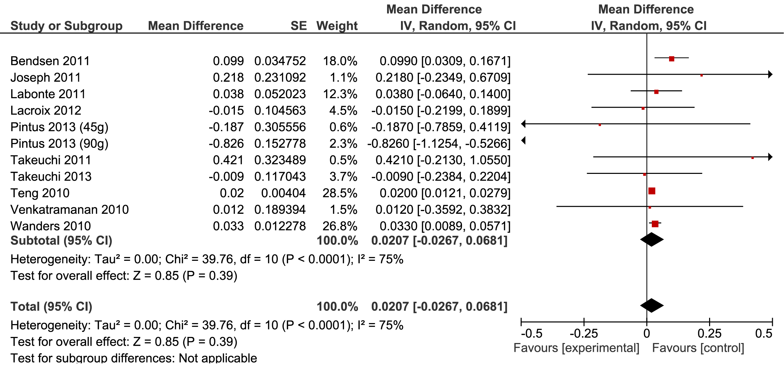
iTFA = industrial TFA, rTFA = ruminant TFA
Figure 2. Change in total cholesterol associated with an increase in TFA in exchange for cis-MUFA equivalent to 1 per cent of energy intake (random effects)

There was a non-significant change in LDL cholesterol associated with a one percent increase in TFA in the diet (0.015 mmol/L, 95% CI = 0.038, 0.066, p = 0.59) (Figure 3a). An increase in LDL was consistent with the results of Brouwer et al, who identified a significant increase in LDL cholesterol with a percent increase in the intake of industrial TFA (0.05 mmol/L, 95% CI = 0.04, 0.06). Results including the Brouwer study are shown in Figure 3b.

(a)
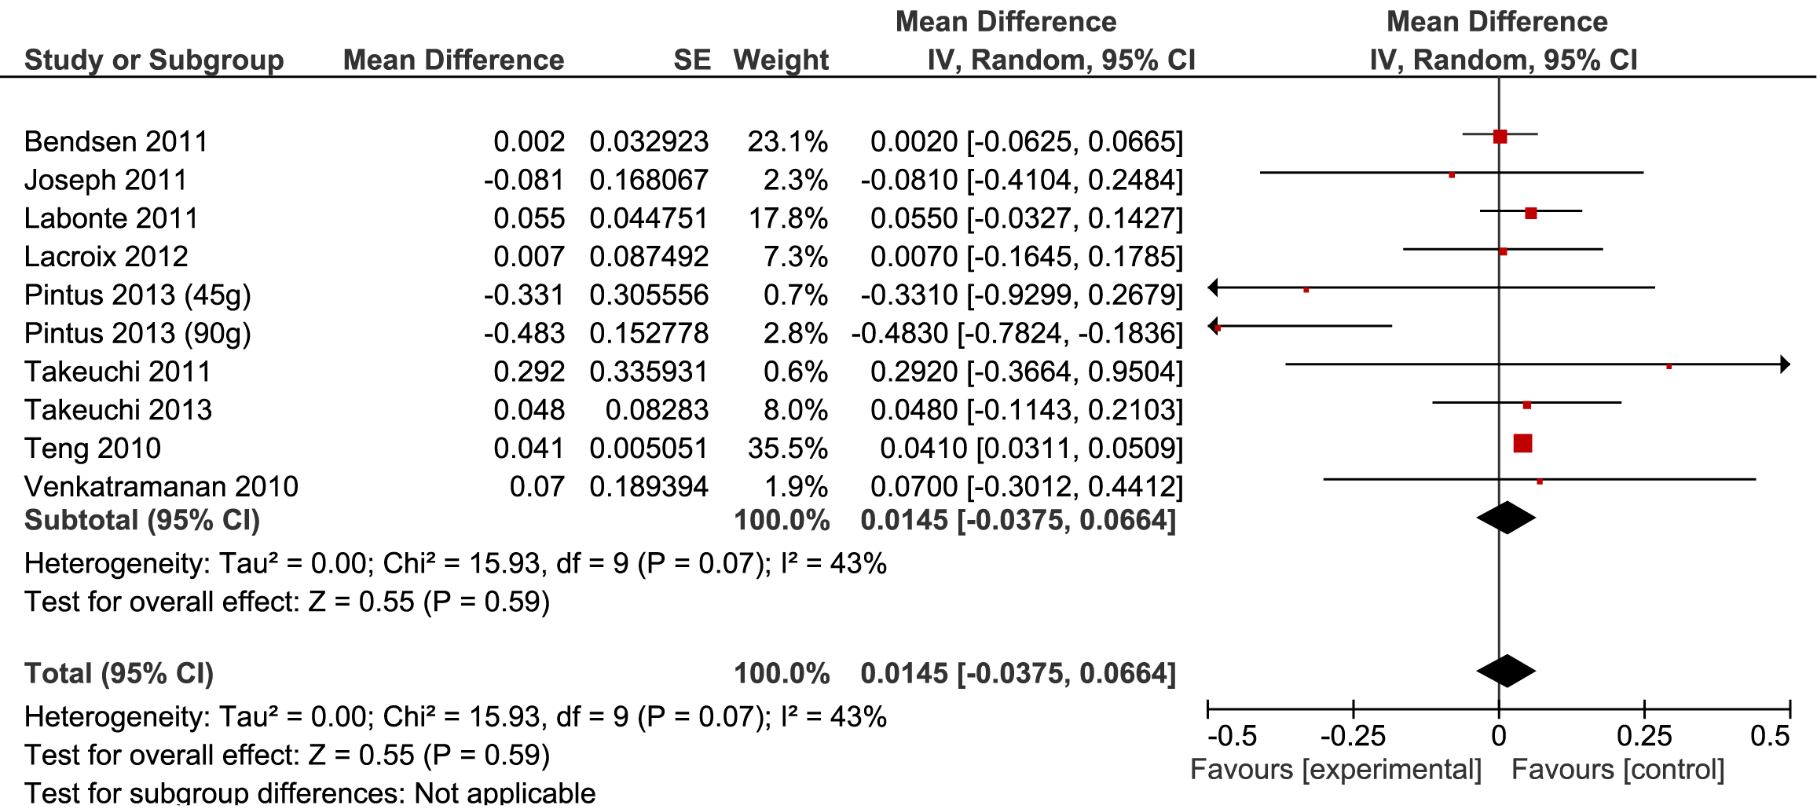
(b)
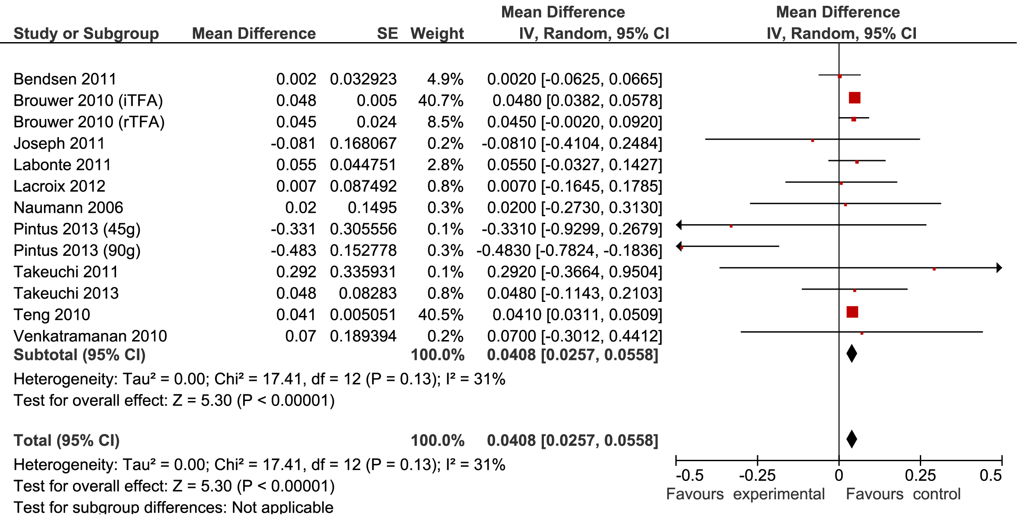
iTFA = industrial TFA, rTFA = ruminant TFA
Figure 3. Change in LDL cholesterol associated with an increase in TFA in exchange for cis-MUFA equivalent to 1 per cent of energy intake (random effects) excluding (a) and including (b) Brouwer et al (2010)

A non-significant inverse relationship between consumption of TFA and change in HDL cholesterol was identified. A one percent increase in TFA, as a percentage of energy intake, was associated with a 0.023 mmol/L (95% CI = -0.052, 0.007) decrease in HDL cholesterol (Figure 4a). These results were consistent with Brouwer et al, who reported a -0.01 mmol/L (95% CI = -0.01, -0.01) and -0.01 (-0.02, 0.01) decrease in HDL cholesterol for a percent increase in industrial and ruminant TFA respectively (all results included Figure 4b).
(a)
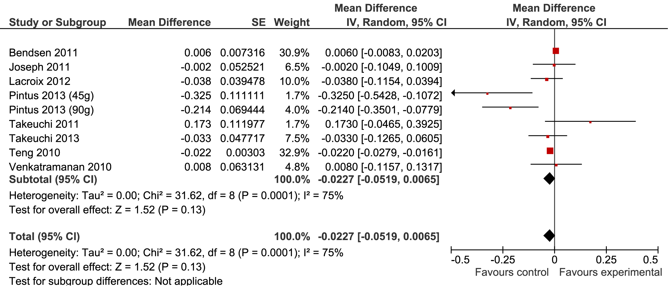
(b)
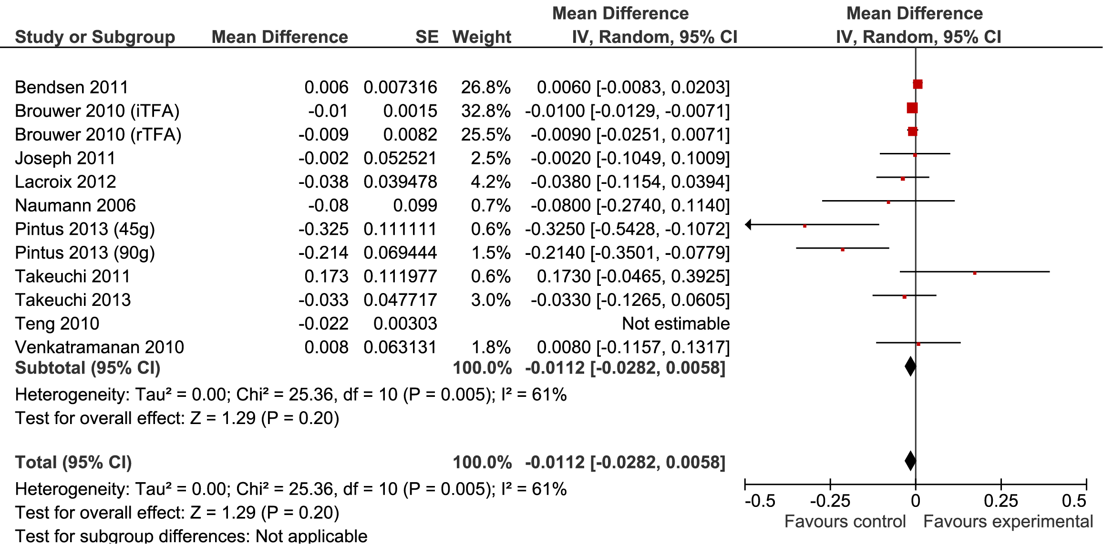
iTFA = industrial TFA, rTFA = ruminant TFA
Figure 4. Change in HDL cholesterol associated with an increase in TFA in exchange for cis-MUFA equivalent to 1 per cent of energy intake (random effects) excluding (a) and including (b) Brouwer et al (2010)

3.3.6 Sensitivity analysis
Three studies were identified as limited in their ability to address the aims of the current review (Takeuchi, et al., 2013; Takeuchi, et al., 2011; Venkatramanan, et al., 2010) (quality scores provided in Table 2). Therefore, these results were removed from the analysis to evaluate their impact and the stability of results. The exclusion of these studies had little impact on the strength and direction of results. With the exclusion of these limited quality studies, a one per cent increase in TFA intake was associated with an increase in total cholesterol of 0.019 mmol/L (95% CI = -0.031, 0.069), increase in LDL of 0.039 mmol/L (95% CI = 0.022, 0.057), and 0.013 mmol/L decrease in HDL (95% CI = -0.025, -0.001).
In a second stage of sensitivity analysis, those studies considered adequate in their ability to address the aims of the current review were also removed from the analysis (Bendsen, et al., 2011; Joseph, et al., 2011; Pintus, et al., 2013). Again, there was no impact on the direction of risk estimates. Estimates for the change in lipid values associated with a one per cent increase in TFA were a 0.021 mmol/L increase in total cholesterol (95% CI = 0.014, 0.029), increase in LDL of 0.045 mmol/L (95% CI = 0.038, 0.051) and a non-significant reduction in HDL cholesterol (-0.015 mmol/L, 95% CI = -0.024, 0.006). Of note, the results of Teng had substantial weight in this analysis and in particular the analysis of the impact of TFA on total cholesterol results (weight = 90%).
Pintus et al and Venkatramanan et al included mildly hyperlipidemic or hypercholesterolemic subjects in their trials. When these results were excluded from the overall analysis a one per cent increase in TFA was associated with a 0.029 mmol/L increase in total cholesterol (95% CI = 0.012, 0.046), 0.045 mmol/L increase in LDL (95% CI = 0.038, 0.051) and a -0.011 mmol/L change in HDL cholesterol (95% CI = -0.020, -0.002).
The study of Teng and colleagues contributed substantial weight to the analysis due to their small error estimates. This is likely due to the large dose of TFA (9.9% of energy intake) which was included in the experimental diet. Therefore, the stability of results with the exclusion of Teng et al were assessed. When these data were removed, a one per cent increase in TFA intake, as a percentage of energy, resulted in little change in total cholesterol (-0.015 mmol/L, 95% CI = -0.117, 0.083), an increase in LDL cholesterol of 0.030 mmol/L (95% CI = -0.001, 0.065) and a decrease in HDL cholesterol (-0.011mmol/L, 95% CI = -0.028, 0.006). While non-significant, the direction of effects for LDL and HDL cholesterol did not change with the removal of Teng et al.

3.3.7 Dose repose analysis
Dose response and potential non-linear relationships between intake of TFA, as a percentage of energy intake, and changes in total, LDL and HDL cholesterol were investigated. There was a high degree of variability in results from different studies. In addition, there was substantial clustering around one per cent intake of TFA, which somewhat limits the ability to assess potential threshold, dose response or nonlinear relationships in the data. Nevertheless, these results suggest a significant increase in both total (Figure 3) and LDL cholesterol (Figure 4) with an increase in TFA intake. In addition, there is a significant negative relationship between TFA dose and change in HDL cholesterol (Figure 5).

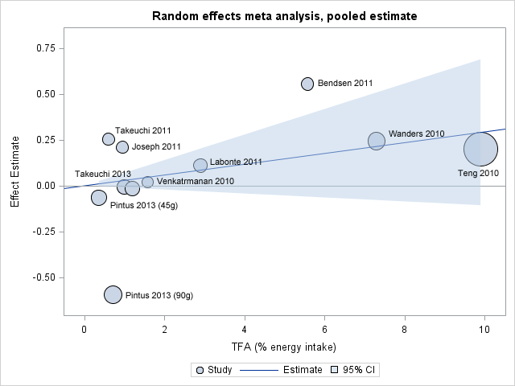
Figure 5. Dose response analysis of change in total cholesterol when cis-MUFA is exchanged for TFA on an isoenergy basis (α = 0 β = 0.029)

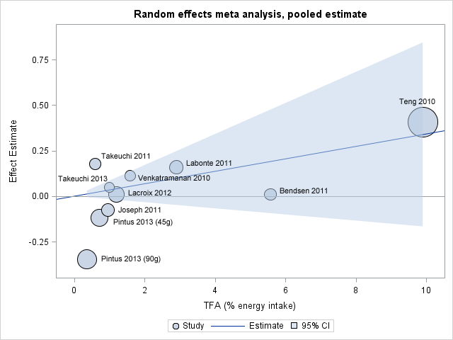

Figure 6. Dose-response analysis of change in LDL cholesterol when cis-MUFA is exchanged for TFA on an isoenergy basis (α = 0 β = 0.034)

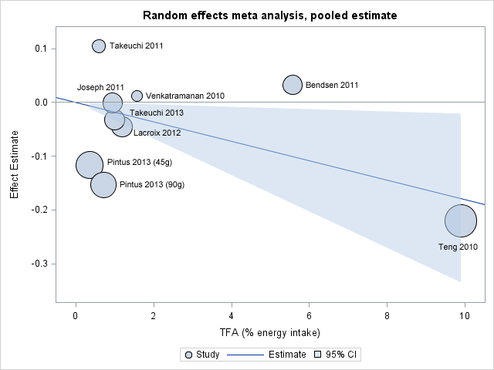
Figure 7. Dose-response analysis of change in HDL cholesterol when cis-MUFA is exchanged forTFA on an isoenergy basis (α = 0 β = -0.018)

3.3.8 Publication bias
There was no evidence to suggest significant bias for total, LDL or HDL cholesterol outcomes. Funnel plots are included in the Appendix 2, Figures 1-3.

Weight of evidence
The results of the current review are consistent with previous evidence which indicates a detrimental effect of consumption of TFA on changes in LDL and HDL blood cholesterol. However, no significant relationship was identified between total cholesterol and intake of TFA. Based on the GRADE criteria, the current review provides high quality evidence for a significant relationship between TFA intake and changes in LDL and HDL cholesterol. In addition, these criteria suggest there is moderate quality evidence for a relationship between dietary TFA and associated changes in total cholesterol. GRADE summary of findings tables are provided in Appendix 3, Table 1.

4.1 Assessment of body of evidence
It is important to note that there are limitations associated with the current review. Some studies attempted to investigate the relationship between TFA and health outcomes in a free living environment and therefore, lacked control over the total diet and physical activity levels of participants. A number of these studies did not assess total energy intake or total dietary lipid intake. It is therefore impossible to attribute changes in cholesterol outcomes to TFA alone. In addition, many of the included studies had small sample sizes and, based on our power calculations, six of the eleven studies had insufficient power to identify significant changes in LDL cholesterol.
However, in spite of these limitations, when considering the existing body of evidence the current review identified a significant change in LDL and HDL cholesterol values which can be attributed to changes in dietary TFA. However, given the size of the effect, and previously identified low intake of TFA in the Australian and New Zealand diet, these changes are unlikely to be biologically meaningful. These results are consistent with the previously published literature and are considered to provide an update the findings of Brouwer et al.

4.2 Applicability to Australia and New Zealand

4.2.1 Intake required for effect
This review identified a small but significant increase in LDL cholesterol and decrease in HDL cholesterol with a one percent increase in TFA intake. Due to the somewhat limited range of TFA intakes within the included studies, it is difficult to assess whether a threshold effect, above which clinical risk associated with changes in blood cholesterol, exists. However, based on the current results (see Figures 2–4), it can be concluded that there is limited risk associated with the current low levels of consumption of TFA intake in the Australian and New Zealand food supply.

4.2.2 Target population
The populations included in the review were geographically diverse. In addition, study participants covered a wide range of ages and included both healthy and hyperlipidemic individuals. Therefore, it is reasonable to assume that results can be generalised to the Australia and New Zealand adult population. However, generalisation of these results to child populations, or those who are acutely ill, is not possible.

Conclusion
This review summarised recent evidence relating to the relationship between intake of TFA and changes in serum blood cholesterol levels. Perhaps due to the well-established causal relationship between intake of TFA and changes in blood lipid values, much of the identified research published since 2010 did not examine the overall relationship between TFA intake and cholesterol outcomes but focussed on more specific questions. For example, there was particular research interest in the differential effects of ruminant and industrial sources of TFA on blood lipid changes, and the role of CLA in body weight change and health. Overall, evidence published between 2010 and 2014 regarding the relationship between TFA intake and change in blood lipids is consistent with the large body of previous research. This work demonstrates a causal relationship between intake of dietary TFA and detrimental changes in LDL and HDL cholesterol values. Although statistically significant, the associated change in LDL and HDL blood lipid values by replacing one per cent of energy from cis-MUFA with TFA was small. Further, results of the accompanying narrative review revealed inconsistent results regarding disease outcomes and TFA intake (Narrative review reference to be included).

5.1 Gaps in the knowledge
In 2009, FSANZ completed a risk assessment of the role of TFA in the Australian and New Zealand food supply. This report identified uncertainty regarding the dose response relationship between intake of TFA and blood lipid values at low levels of intake (Food Standards Australia New Zealand, 2009). The current review suggests that recently published literature does not make a substantial change to the existing evidence. This is due to the high variability of results at low levels of TFA intake which are relevant to the Australian and New Zealand context. Further research into the dose response across a wide range of intakes, and in particular those below one per cent of energy intake, may be of interest.

5.2 Implications for Australia and New Zealand
In 2009 TFA intake in Australia and New Zealand was estimated to be around 0.6 per cent of energy intake (Food Standards Australia New Zealand, 2009). This level of intake meets the WHO recommendation which provides that individuals should consume less than one per cent of energy intake from TFA (Nishida & Uauy, 2009). Previous evidence, and the results of the current review, indicates that this level of intake is associated with small changes in blood lipid values which are variable at low levels of intake.
When evaluating changes in current recommendations and guidelines relating to TFA in Australia and New Zealand a number of potential complexities should be considered. For example, TFA is difficult to avoid in a nutritionally adequate diet due to the TFA contained within meat and dairy products. Therefore, recommendations to further reduce consumption of these products in Australia and New Zealand, with the aim of minimising TFA consumption, may have adverse effects on intake of other nutrients such as calcium and iron. The health risk associated with deficiencies in such nutrients may be greater than the risk associated with the small intake of TFA. In addition, further reductions would require replacement of TFA with another nutrient. As highlighted by Booker and Mann, it is important to consider the effect of the replacement nutrient on overall disease risk (Booker & Mann, 2005). The results of this review, in addition to the results of previous reviews, suggest that the existing guidelines which relate to intake of TFA in the Australia and New Zealand diet are sufficient. There appears to be a little risk associated with the low level of intake as reported in 2009. However, to ensure that the level of TFA in the food supply remains low, ongoing monitoring of industry and population intakes is recommended.

References
Bendsen, N.T., Chabanova, E., Thomsen, H.S., Larsen, T.M., Newman, J.W., Stender, S., . . . Astrup, A. (2011). Effect of trans fatty acid intake on abdominal and liver fat deposition and blood lipids: A randomized trial in overweight postmenopausal women. Nutrition and Diabetes, 1(1). doi: http://dx.doi.org/10.1038/nutd.2010.4
Booker, C., & Mann, J. (2005). The relationship between saturated and trans unsaturated fatty acids and LDL-cholesterol and coronary heart disease: A review undertaken for Food Standards Australia New Zealand (Translator, Trans. Editor Ed.^Eds.).
Brouwer, I.A., Wanders, A.J., & Katan, M.B. (2010). Effect of animal and industrial trans fatty acids on HDL and LDL cholesterol levels in humans--a quantitative review. PloS one, 5(3), e9434. doi: 10.1371/journal.pone.0009434
Clarke, R., Frost, C., Collins, R., Appleby, P., & Peto, R. (1997). Dietary lipids and blood cholesterol: quantitative meta-analysis of metabolic ward studies. BMJ, 314(7074), 112-117.
Das, D.K. (2003). Cardioprotection with high-density lipoproteins: fact or fiction? Circulation research, 92(3), 258-260.
Food Standards Australia New Zealand. (2009). Risk Assessment Report: Trans Fatty Acids In The New Zealand And Australian Food Supply (Translator, Trans. Editor Ed.^Eds.).
Gagliardi, A.C., Maranhao, R.C., de Sousa, H.P., Schaefer, E.J., & Santos, R.D. (2010). Effects of margarines and butter consumption on lipid profiles, inflammation markers and lipid transfer to HDL particles in free-living subjects with the metabolic syndrome. Eur J Clin Nutr, 64(10), 1141-1149. doi: 10.1038/ejcn.2010.122
Joseph, S.V., Jacques, H., Plourde, M., Mitchell, P.L., McLeod, R.S., & Jones, P.J. (2011). Conjugated linoleic acid supplementation for 8 weeks does not affect body composition, lipid profile, or safety biomarkers in overweight, hyperlipidemic men. J Nutr, 141(7), 1286-1291. doi: 10.3945/jn.110.135087
Labonte, M.E., Couture, P., Paquin, P., Chouinard, Y., Lemieux, S., & Lamarche, B. (2011). Comparison of the impact of trans fatty acids from ruminant and industrial sources on surrogate markers of cholesterol homeostasis in healthy men. Mol Nutr Food Res, 55 Suppl 2, S241-247. doi: 10.1002/mnfr.201000492
Lacroix, E., Charest, A., Cyr, A., Baril-Gravel, L., Lebeuf, Y., Paquin, P., . . . Lamarche, B. (2012). Randomized controlled study of the effect of a butter naturally enriched in trans fatty acids on blood lipids in healthy women. Am J Clin Nutr, 95(2), 318-325. doi: 10.3945/ajcn.111.023408
Mensink, R.P. (2005). Metabolic and health effects of isomeric fatty acids. Current opinion in lipidology, 16(1), 27-30.
Mensink, R.P., Zock, P.L., Kester, A.D., & Katan, M.B. (2003). Effects of dietary fatty acids and carbohydrates on the ratio of serum total to HDL cholesterol and on serum lipids and apolipoproteins: a meta-analysis of 60 controlled trials. The American journal of clinical nutrition, 77(5), 1146-1155.
Mozaffarian, D., Aro, A., & Willett, W.C. (2009). Health effects of trans-fatty acids: experimental and observational evidence. European journal of clinical nutrition, 63 Suppl 2, S5-21. doi: 10.1038/sj.ejcn.1602973
Mozaffarian, D., & Clarke, R. (2009). Quantitative effects on cardiovascular risk factors and coronary heart disease risk of replacing partially hydrogenated vegetable oils with other fats and oils. European journal of clinical nutrition, 63 Suppl 2, S22-33. doi: 10.1038/sj.ejcn.1602976
Mozaffarian, D., Katan, M.B., Ascherio, A., Stampfer, M.J., & Willett, W.C. (2006). Trans fatty acids and cardiovascular disease. The New England journal of medicine, 354(15), 1601-1613. doi: 10.1056/NEJMra054035
Naumann, E., Carpentier, Y.A., Saebo, A., Lassel, T.S., Chardigny, J.M., Sebedio, J.L., . . . Fun, C.L.A.S.G. (2006). Cis-9, trans- 11 and trans-10, cis-12 conjugated linoleic acid (CLA) do not affect the plasma lipoprotein profile in moderately overweight subjects with LDL phenotype B. Atherosclerosis, 188(1), 167-174. doi: 10.1016/j.atherosclerosis.2005.10.019
Nishida, C., & Uauy, R. (2009). WHO Scientific Update on health consequences of trans fatty acids: introduction. European journal of clinical nutrition, 63 Suppl 2, S1-4. doi: 10.1038/ejcn.2009.13
Pintus, S., Murru, E., Carta, G., Cordeddu, L., Batetta, B., Accossu, S., . . . Banni, S. (2013). Sheep cheese naturally enriched in alpha-linolenic, conjugated linoleic and vaccenic acids improves the lipid profile and reduces anandamide in the plasma of hypercholesterolaemic subjects. Br J Nutr, 109(8), 1453-1462. doi: 10.1017/s0007114512003224
Reuss, R., McKague, E., Webb, T., Cunningham, J., Joseph, B., Thoma, C., . . . Mackerras, D. (2009). Trans fatty acids in Australia and New Zealand. Australasian Epidemiologist, 16(1), 20-22.
Takeuchi, H., Kutsuwada, T., Shirokawa, Y., Harada, S., & Sugano, M. (2013). Supplementation with 1% energy trans fatty acids had little effect on serum cholesterol levels in healthy young Japanese women. Biosci Biotechnol Biochem, 77(6), 1219-1222.
Takeuchi, H., Yamaki, M., Hirose, K., Hienae, C., Tabuchi, E., & Sugano, M. (2011). Effect of a 0.6% energy trans fatty acid intake on serum cholesterol concentrations in healthy young Japanese subjects. Biosci Biotechnol Biochem, 75(11), 2243-2245.
Teng, K.T., Voon, P.T., Cheng, H.M., & Nesaretnam, K. (2010). Effects of partially hydrogenated, semi-saturated, and high oleate vegetable oils on inflammatory markers and lipids. Lipids, 45(5), 385-392. doi: 10.1007/s11745-010-3416-1
Venkatramanan, S., Joseph, S.V., Chouinard, P.Y., Jacques, H., Farnworth, E.R., & Jones, P.J. (2010). Milk enriched with conjugated linoleic acid fails to alter blood lipids or body composition in moderately overweight, borderline hyperlipidemic individuals. J Am Coll Nutr, 29(2), 152-159.
Wanders, A.J., Brouwer, I.A., Siebelink, E., & Katan, M.B. (2010). Effect of a high intake of conjugated linoleic acid on lipoprotein levels in healthy human subjects. PLoS One, 5(2), e9000. doi: 10.1371/journal.pone.0009000
Wilkins, T., Gillies, R.A., & Davies, K. (2005). EMBASE versus MEDLINE for family medicine searches: can MEDLINE searches find the forest or a tree? Canadian family physician Medecin de famille canadien, 51, 848-849.

Appendices

Appendix 1

In order to isolate the effect of TFA on changes in serum lipids we made use of the equations provided by Mensink et al (2003).

The equations used to convert serum lipid values to those which would be expected from a diet in which dietary fats were either TFA or MUFA are provided below.

Total cholesterol
= reported total cholesterol - (0.069 + 0.006) * 12:0 - (0.059 + 0.006)*14:0 - (0.041 + 0.006)*16:0 - (-0.01 + 0.006)*18:0 -(-0.021+ 0.006)* - PUFA (0.036 + 0.006)*(Total SFA excluding 12:0, 14:0, 16:0 18:0)

LDL cholesterol
= reported LDL cholesterol - (0.052 + 0.009) * 12:0 - (0.048 + 0.009)*14:0 - (0.039 + 0.009)*16:0 - (-0.004 + 0.009)*18:0 - (-0.019+ 0.009)* PUFA - (0.032 + 0.009)*(Total SFA excluding 12:0, 14:0, 16:0 18:0) – (0.04 + 0.009) * TFA in control diet/period

HDL cholesterol
= reported HDL cholesterol - (0.027 – 0.008) * 12:0 - (0.018 – 0.008)*14:0 - (0.01 – 0.008)*16:0 - (0.002 – 0.008)*18:0 - (0.008– 0.008)* PUFA - (0.01 – 0.008)*(Total SFA excluding 12:0, 14:0, 16:0 18:0) – (0.04 – 0.008)

Table 1. Final data used in analyses
Study | Control |  | Intervention
 | mean (mmol/L) | std | mean (mmol/L) | std
Total cholesterol
Bendsen 2011 | 3.58 | 0.95 | 4.13 | 1.03
Joseph 2011 | 6.32 | 1.14 | 6.53 | 1.14
Labonte 2012 | 4.06 | 0.93 | 4.17 | 0.97
Lacroix 2012 | 4.95 | 0.98 | 4.93 | 0.98
Pintus 2013 (45g) | 6.39 | 0.71 | 6.33 | 0.71
Pintus 2013 (90g) | 6.43 | 0.71 | 5.83 | 0.45
Takeuchi 2011 | 3.96 | 0.67 | 4.21 | 0.75
Takeuchi 2013 | 4.69 | 0.67 | 4.68 | 0.72
Teng 2010 | 4.15 | 0.26 | 4.35 | 0.26
Venkatramanan 2010 | 4.93 | 1.16 | 4.95 | 1.16
Wanders 2010 | 4.05 | 0.70 | 4.29 | 0.75
LDL
Bendsen 2011 | 3.15 | 0.90 | 3.16 | 0.93
Joseph 2011 | 2.25 | 0.83 | 2.17 | 0.83
Labonte 2012 | 2.52 | 0.80 | 2.68 | 0.90
Lacroix 2012 | 2.76 | 0.82 | 2.77 | 0.84
Pintus 2013 (45g) | 4.21 | 0.71 | 4.09 | 0.52
Pintus 2013 (90g) | 4.19 | 0.71 | 3.84 | 0.32
Takeuchi 2011 | 2.18 | 0.70 | 2.35 | 0.72
Takeuchi 2013 | 2.54 | 0.48 | 2.59 | 2.74
Teng 2010 | 2.31 | 0.32 | 2.72 | 0.32
Venkatramanan 2010 | 3.01 | 1.16 | 3.12 | 0.78
HDL
Bendsen 2011 | 1.25 | 0.20 | 1.28 | 0.29
Joseph 2011 | 0.49 | 0.26 | 0.49 | 0.26
Lacroix 2012 | 1.69 | 0.37 | 1.64 | 0.37
Pintus 2013 (45g) | 1.53 | 0.26 | 1.42 | 0.19
Pintus 2013 (90g) | 1.59 | 0.32 | 1.43 | 0.13
Takeuchi 2011 | 1.42 | 0.23 | 1.53 | 0.31
Takeuchi 2013 | 1.78 | 0.27 | 1.75 | 0.28
Teng 2010 | 1.63 | 0.19 | 1.40 | 0.19
Venkatramanan 2010 | 1.08 | 0.39 | 1.09 | 0.39
iTFA = industrial TFA, rTFA = ruminant TFA
Table 2. Summary of study characteristics and findings

Reference | Study design | Objectives | Sample size | Participants | Intervention | Methods | Additional comments
(Bendsen et al., 2011) | Randomised, double blind, parallel | Examine the effect of industrially produced TFA on the liver and abdominal region in TFA depleted overweight post-menopausal women. Secondary outcome was to confirm previous findings of the effects of TFA on blood lipids | Initial: 52, final: 49  Reason for loss:  lack of time (n = 2), felt medicalised (n = 1) | 100% female, post-menopausal, 40-70 years, iTFA depleted | 15.7g/day industrially produced TFA | Oil included in carrot bread rolls of which participants consumed 2 per day which equalled 26g / day of test fat and total of 2500kJ (7% energy protein, 41% energy fat and 51% energy carbohydrate). The 16 week program was isocaloric and therefore food items from their habitual diet were substituted. | Subjects recruited from a prior 12 week weight loss intervention. Despite intentions, both control and TFA groups lost weight during intervention (mean 1.1kg).
(Gagliardi et al., 2010) | Randomised, single blind parallel | Examine the effect of daily servings of butter, no TFA margarine or plant sterol margarine on lipids, apolipoproteins, biomarkers of inflammation and endothelial dysfunction and the transfer of lipids to HDL particles in those with metabolic syndrome. | Initial: 75 final: 53. Reason for loss:  22 excluded or dropped out. Primary reason was self-reported noncompliance. | 62.3% female, 47.4 years +/1 9.4,  metabolic syndrome | Butter - TFA: 0.617, Non trans margarine TFA: 0.067,  Plant sterol - TFA: 0.048 | Subjects continued regular diet and activity in the free living state for the 5 week intervention period. Spreads were provided in daily packages for use. Spreads provided approximately equal amount of total lipids (12.6-12.9g/day) and calories. | SFA was the outcome of interest and therefore the major difference between groups is the intake of SFA. Little difference in absolute quantity of TFA between groups.
(Joseph et al., 2011) | Randomised, double blinded, crossover | Evaluate the effectiveness of 2 forms of CLA in modulating body weight and body composition, as well as blood lipids, in overweight hyperlipidaemia men in a free living environment | Initial: 36 final: 27 . Reason for loss:  Unrelated to the protocol (n = 8) mononucleosis (n = 1) | 100% male, 18-60 years, hyperlipidemic | 3.5 g/day of safflower oil (control),  3.5g /day of 50:50 t10, c12 and c9, t11 CLA oil, and  3.5g/ day of c9, t11 CLA oil containing 2.7g of total CLA) | 3 x 8 weeks with 4 week washout periods.  FA's administered as oil mixed into 150g fat free, sugar free yoghurt. Usual dietary and activity habits maintained. Additional food supplied but not required (supper buffet) | Diet arm including 3.5g /day of 50:50 t10, c12 and c9, t11 CLA oil did not meet review inclusion criteria. Data was excluded from the current analysis.
(Labonte et al., 2011) | Randomised, double blind, crossover, Latin square design | Compared the impact of very high dietary intake of iTFA and rTFA on markers of cholesterol absorption and synthesis in healthy men | Initial: 48 final:38 . Reason for loss:  moved (n = 2), protocol too demanding (n = 6), non-compliant (n = 1), health reasons unrelated to the study (n = 1). | 100% male, 32.8 +/- 15 years, healthy | high rTFA =10.2g / 2500 kcal,  moderate rTFA = 4.2g / 2500 kcal,  high iTFA = 10.2g / 2500 kcal,  low TFA (control) = 2.2g / 2500 kcal | Diets lasted 4 weeks each. Each participant was assigned to 4 different isocaloric diets which lasted 4 weeks each. Wash out periods of 3-12 weeks between protocols. | Results for the moderate TFA diet were not included in this publication.
(Lacroix et al., 2012) | Randomised double blind, crossover | Investigate the effect of high but achievable intake of rTFAs on plasma lipid concentrations among healthy women with a broad range of plasma cholesterol concentrations | Initial: 72 final: 61. Reason for loss:  drop out: n = 8 study protocol too demanding, excluded : n = 2 post-menopausal status changed during study period, 1 missing data | 100% female, 38.3+/- 17 years , healthy | rTFA = 3.7 g/day (1.5% energy intake), low TFA (control) = 0.9g/day (0.3% of energy intake) of rTFA. | 2 x 4 weeks, 3 day washout between diets. Butter enriched with rTFA obtained by altering the cow’s diets. Each participant was assigned to 2 sequences of 2 different, iso caloric diets lasting 4 weeks each. Diets were separated by a 3 day wash out. Experimental diets were rTFA and control was low in rTFA. Differences between SFA and UnSFA were minimised between diets. | BMI by diet interaction identified. Overweight associated with worse blood lipid outcomes.
(Pintus et al., 2013) | Randomised, single blind, controlled crossover | Assess the impact of enriched dairy products on the plasma lipid profile and endocannabinoids in hypercholesterolemic patients. | Initial: 42 final: 42. | 30-60 years, 55% female, hypercholesterolemia | 90g enriched cheese - total trans MUFA: 2.3 total Trans PUFA: 0.3 Total CLA: 0.6 90g control cheese - total trans MUFA: 0.8 total Trans PUFA: 0.1 Total CLA:0.2. CLA supplement = 0.8g/day. | 4 x 3 weeks with 3 week wash out periods.90g of control or enriched cheese, 45g of control or enriched cheese. Randomly assigned to enriched or control cheese followed by 3 week washout. This was repeated with the 45g cheese intake. A sub sample (n = 20) who completed the main study were randomly assigned to CLA pill or placebo. | Increase in CLA achieved via bio-fortification. Difference in control and intervention was 0.8g/day due to a problem with conversions.
(Takeuchi et al., 2011) | Randomised, double blind, crossover | Examine the influence of 0.6% increase in TFA, as a percentage of energy intake, on serum lipid concentrations in a healthy young Japanese population. | Initial: 13 final: 12. Reason for loss: personal reasons unrelated to trial (n = 1) | 20-28 years, 77% female, healthy | Control cookie: 0.04g,  TFA cookie: 1.13g TFA (equivalent to 0.6% increase in TFA). | 2 x 4 week treatment periods with 12 week wash out period in between. 1 cookie per day which contained rape seed oil (control) or partially hydrogenated rape seed oil (TFA, 34.5% trans octadeccenoic acid). | Small sample size limits conclusions. Suggest larger scale studies and those using higher intakes of TFA are needed. The 0.6% increase in TFA was thought to represent the upper limit of TFA intake in Japan.
(Takeuchi et al., 2013) | Randomised, double blind, parallel | Examine the influence of 1% increase in TFA on serum lipid concentrations in a healthy young Japanese population. | Initial: 65 final: 65. | 18-22 years, 100% female, healthy | TFA cookie: 1.8g TFA (equivalent to 0.6% increase in TFA). | 4 weeks trial. 1 cookie per day which contained rape seed oil (control) or partially hydrogenated rape seed oil (TFA, 34.5% trans octadeccenoic acid).
(Teng et al., 2010) | Randomised, single blind, crossover | Compare the effects of a high oleic vegetable oil with that of a partially hydrogenated, and an un-hydrogenated and more saturated vegetable oil on serum inflammatory markers and blood lipids. | Initial: 43 final: 41Reason for loss: medical problems (n = 2) | 28.8 +/- 9.1 years, 80% female, healthy | Oleic: TFA = 0% energy intake,  Soy bean: FA = 9.9% energy intake  Palm oil: TFA = 0% energy intake | 3 x 5 week dietary intervention separated by 7 day washout period. Subjects consumed 54g of test fats which were incorporated into a cooked meal. Test fats were high oleic palm olein, partially hydrogenated soybean oil, and palm stearin. Subjects were provided with meals with a 5 day rotational menu and provided test fats and guidelines for home prepared meals on the weekends.
(Venkatramanan et al., 2010) | Randomised, 3 phase, crossover, single blind | Determine whether the consumption of milk naturally or synthetically enriched with CLA alters blood lipids, liver function, C reactive protein, tumour necrosis factor alpha, body weight and body composition in moderately overweight, borderline hyperlipidaemia participants. | Initial: 18 final: 15. Reason for loss:  Personal reasons (n = 2) and pregnancy (n = 1) | 46.6 years+/- 2.0, 44% female, moderately overweight, borderline hyperlipidaemia | Natural CLA: 4.2% of milk fats,  iTFA: 4.2% and untreated control. | 3 x 8 week dietary periods separated by 4 week wash out period. Participants consumed 1000mls/day of milk naturally enriched with CLA, milk synthetically enriched with CLA or untreated milk in addition to their usual diet (uncontrolled). Diet arm which included synthetic CLA did not meet review inclusion criteria and was therefore excluded from the analysis. | Dose of CLA in natural products achieved via bio-fortification, and therefore in the study, is limited by ability to naturally increase levels via animal feed.
(Wanders et al., 2010) | Randomised, single blind, multiple crossover trial | Study the effect of high doses of CLA on lipoprotein levels in human RCTs | Initial: 63 final: 61. Reason for loss:  Illness and personal reasons. Both unrelated to the trial. | 30.9 +/- 13.7, years, 59% female, healthy | High oleic acid, CLA, and vegetable oil Total TFA intake was 1.6% higher in CLA diet compared to iTFA. | Diets were identical other than the 7% of total energy as CLA, industrial TFA or oleic acid. iTFA used as a positive control. CLA arm did not meet inclusion criteria of the current review and these results were excluded from the analysis. | Men were more sensitive to the effects of TFA than women. No washout period between diets.
CLA: conjugated linoleic acid, HDL: high density lipoprotein, iTFA: industrial trans fatty acids, LDL: low density lipoprotein, MUFA: monounsaturated fatty acids, rTFA: ruminant trans fatty acids, TFA: Trans fatty acids
Excluded full text studies

No dietary TFA intervention or insufficient information
Anton, S. D., Heekin, K., Simkins, C., & Acosta, A. (2013). Differential effects of adulterated versus unadulterated forms of linoleic acid on cardiovascular health. J Integr Med, 11(1), 2-10.
Asghari, G., Sheikholeslami, S., Mirmiran, P., Chary, A., Hedayati, M., Shafiee, A., & Azizi, F. (2012). Effect of pomegranate seed oil on serum TNF-alpha level in dyslipidemic patients. Int J Food Sci Nutr, 63(3), 368-371.
Bjermo, H., Iggman, D., Kullberg, J., Dahlman, I., Johansson, L., Persson, L., Berglund, J., Pulkki, K., Basu, S., Uusitupa, M., Rudling, M., Arner, P., Cederholm, T., Ahlstrom, H., & Riserus, U. (2012). Effects of n-6 PUFAs compared with SFAs on liver fat, lipoproteins, and inflammation in abdominal obesity: a randomized controlled trial. Am J Clin Nutr, 95(5), 1003-1012.
Campos Mondragon, M. G., Oliart Ros, R. M., Martinez Martinez, A., Mendez Machado, G. F., & Angulo Guerrero, J. O. (2013). Metabolic syndrome reversion by polyunsaturated fatty acids ingestion. [Spanish] Medicina Clinica, 141(12), 513-518.
Eady S, Wallace A, Willis J, & Framptom C. (2011). Consumption of a plant sterol-based spread derived from rice bran oil is effective at reducing plasma lipid levels in mildly hypercholesterolaemic individuals. Br J Nutr, 105(12), 1808-1818.
de Luis, D. A., de la Fuente, B., Izaola, O., Conde, R., Gutierrez, S., Morillo, M., & Teba Torres, C. (2011). Double blind randomized clinical trial controlled by placebo with an alpha linoleic acid and prebiotic enriched cookie on risk cardiovascular factor in obese patients. Nutr Hosp, 26(4), 827-833.
Gabert, L., Vors, C., Louche-Pelissier, C., Sauvinet, V., Lambert-Porcheron, S., Drai, J., Laville, M., Desage, M., & Michalski, M. C. (2011). 13C tracer recovery in human stools after digestion of a fat-rich meal labelled with [1,1,1-13C3]tripalmitin and [1,1,1-13C3]triolein. Rapid Commun. Mass Spectrom., 25(19), 2697-2703.
Gebauer, S. K., Tracy, R. P., & Baer, D. J. (2013). Comparison of stearic acid versus monounsaturated fatty acids on hemostatic factors in healthy men fed controlled diets. FASEB J. Conference: Experimental Biology, 20130420(20130424).
Heggen E, Granlund L, Pedersen JI, Holme I, Ceglarek U, Thiery J, Kirkhus B, & Tonstad S. (2010). Plant sterols from rapeseed and tall oils: effects on lipids, fat-soluble vitamins and plant sterol concentrations. Nutr Metab Cardiovasc Dis, 20(4), 258-265.
Iggman, D., Gustafsson, I. B., Berglund, L., Vessby, B., Marckmann, P., & Riserus, U. (2011). Replacing dairy fat with rapeseed oil causes rapid improvement of hyperlipidaemia: a randomized controlled study. J Intern Med, 270(4), 356-364.
Intorre, F., Foddai, M. S., Azzini, E., Martin, B., Montel, M. C., Catasta, G., Toti, E., Finotti, E., Palomba, L., Venneria, E., Raguzzini, A., Fumagalli, A., Testa, M. F., Rossi, L., & Maiani, G. (2011). Differential effect of cheese fatty acid composition on blood lipid profile and redox status in normolipidemic volunteers: a pilot study. Int J Food Sci Nutr, 62(6), 660-669.
Mateo-Gallego, R., Perez-Calahorra, S., Cenarro, A., Bea, A. M., Andres, E., Horno, J., Ros, E., & Civeira, F. (2012). Effect of lean red meat from lamb v. lean white meat from chicken on the serum lipid profile: a randomised, cross-over study in women. Br J Nutr, 107(10), 1403-1407.
McAfee, A. J., McSorley, E. M., Cuskelly, G. J., Fearon, A. M., Moss, B. W., Beattie, J. A., Wallace, J. M., Bonham, M. P., & Strain, J. J. (2011). Red meat from animals offered a grass diet increases plasma and platelet n-3 PUFA in healthy consumers. Br J Nutr, 105(1), 80-89.
McDaniel, J., Askew, W., Bennett, D., Mihalopoulos, J., Anantharaman, S., Fjeldstad, A. S., Rule, D. C., Nanjee, N. M., Harris, R. A., & Richardson, R. S. (2013). Bison meat has a lower atherogenic risk than beef in healthy men. Nutr Res, 33(4), 293-302
Mirmiran, P., Fazeli, M. R., Asghari, G., Shafiee, A., & Azizi, F. (2010). Effect of pomegranate seed oil on hyperlipidaemic subjects: a double-blind placebo-controlled clinical trial. Br J Nutr, 104(3), 402-406.
Roussell, M. A., Hill, A. M., Gaugler, T. L., West, S. G., Heuvel, J. P., Alaupovic, P., Gillies, P. J., & Kris-Etherton, P. M. (2012). Beef in an Optimal Lean Diet study: effects on lipids, lipoproteins, and apolipoproteins. Am J Clin Nutr, 95(1), 9-16.
Sarrafzadegan, N., Sadeghi, M., Ghaffarpasand, F., Alisaeidi, A., Sanei, H., Zakeri, H., Rastegar, T., Amiri, A., & Dehghankhalili, M. (2012). Interleukin-6 and E-selectin in acute coronary syndromes and stable angina pectoris: A comparative study. Herz, 37(8), 926-930.
Tholstrup, T., Hjerpsted, J., & Raff, M. (2011). Palm olein increases plasma cholesterol moderately compared with olive oil in healthy individuals. Am J Clin Nutr, 94(6), 1426-1432.
Werner, L. B., Hellgren, L. I., Raff, M., Jensen, S. K., Petersen, R. A., Drachmann, T., & Tholstrup, T. (2013). Effects of butter from mountain-pasture grazing cows on risk markers of the metabolic syndrome compared with conventional Danish butter: a randomized controlled study. Lipids Health Dis, 12, 99.
CLA supplement
Asp, M. L., Collene, A. L., Norris, L. E., Cole, R. M., Stout, M. B., Tang, S. Y., Hsu, J. C., & Belury, M. A. (2011). Time-dependent effects of safflower oil to improve glycemia, inflammation and blood lipids in obese, post-menopausal women with type 2 diabetes: A randomized, double-masked, crossover study. Clinical Nutrition, 30(4), 443-449.
Bulut, S., Bodur, E., Colak, R., & Turnagol, H. (2013). Effects of conjugated linoleic acid supplementation and exercise on post-heparin lipoprotein lipase, butyrylcholinesterase, blood lipid profile and glucose metabolism in young men. [Conference Paper]. Chem Biol Interact, 203(1), 323-329.
Chen, S. C., Lin, Y. H., Huang, H. P., Hsu, W. L., Houng, J. Y., & Huang, C. K. (2012). Effect of conjugated linoleic acid supplementation on weight loss and body fat composition in a Chinese population. Nutrition, 28(5), 559-565.
Racine, N. M., Watras, A. C., Carrel, A. L., Allen, D. B., McVean, J. J., Clark, R. R., O'Brien, A. R., O'Shea, M., Scott, C. E., & Schoeller, D. A. (2010). Effect of conjugated linoleic acid on body fat accretion in overweight or obese children. Am J Clin Nutr, 91(5), 1157-1164.
Pfeuffer, M., Fielitz, K., Laue, C., Winkler, P., Rubin, D., Helwig, U., Giller, K., Kammann, J., Schwedhelm, E., Boger, R. H., Bub, A., Bell, D., & Schrezenmeir, J. (2011). CLA does not impair endothelial function and decreases body weight as compared with safflower oil in overweight and obese male subjects. J Am Coll Nutr, 30(1), 19-28.
Blood cholesterol not an outcome / adequately recorded
Golomb, B. A., Evans, M. A., White, H. L., & Dimsdale, J. E. (2012). Trans fat consumption and aggression. PLoS One, 7(3), e32175
Gurdeniz, G., Rago, D., Bendsen, N. T., Savorani, F., Astrup, A., & Dragsted, L. O. (2013). Effect of trans Fatty Acid Intake on LC-MS and NMR Plasma Profiles. PLoS One, 8(7).
McGowan, M. M., Eisenberg, B. L., Lewis, L. D., Froehlich, H. M., Wells, W. A., Eastman, A., Kuemmerle, N. B., Rosenkrantz, K. M., Barth Jr, R. J., Schwartz, G. N., Li, Z., Tosteson, T. D., Beaulieu Jr, B. B., & Kinlaw, W. B. (2013). A proof of principle clinical trial to determine whether conjugated linoleic acid modulates the lipogenic pathway in human breast cancer tissue. Breast Cancer Res Treat, 138(1), 175-183.
Smit, L. A., Katan, M. B., Wanders, A. J., Basu, S., & Brouwer, I. A. (2011). A high intake of trans fatty acids has little effect on markers of inflammation and oxidative stress in humans. J Nutr, 141(9), 1673-1678.
No original results
Aronis, K. N., Khan, S. M., & Mantzoros, C. S. (2012). Effects of trans fatty acids on glucose homeostasis: A meta-analysis of randomized, placebo-controlled clinical trials. Am J Clin Nutr, 96(5), 1093-1099.
Gebauer, S. K., Destaillats, F., Mouloungui, Z., Candy, L., Bezelgues, J. B., Dionisi, F., & Baer, D. J. (2011). Effect of trans fatty acid isomers from ruminant sources on risk factors of cardiovascular disease: study design and rationale. Contemp Clin Trials, 32(4), 569-576.
Trumbo, P. R., & Shimakawa, T. (2011). Tolerable upper intake levels for trans fat, saturated fat, and cholesterol. Nutr Rev, 69(5), 270-278
Not a randomised controlled trial
Glew, R. H., Chuang, L. T., Berry, T., Okolie, H., Crossey, M. J., & VanderJagt, D. J. (2010). Lipid profiles and trans fatty acids in serum phospholipids of semi-nomadic Fulani in northern Nigeria. J Health Popul Nutr, 28(2), 159-166.
Sartika, R. A. (2011). Effect of trans fatty acids intake on blood lipid profile of workers in East Kalimantan, Indonesia. Malays J Nutr, 17(1), 119-127.
Nazeminezhad, R., Tajfard, M., Latiff, L. A., Mouhebati, M., Esmaeily, H., Ferns, G. A. A., Ghayour-Mobarhan, M., & Rahimi, H. R. (2014). Dietary intake of patients with angiographically defined coronary artery disease and that of healthy controls in Iran. Eur J Clin Nutr, 68(1), 109-113.
Less than 3 weeks intervention duration
Svensson, J., Rosenquist, A., & Ohlsson, L. (2011). Postprandial lipid responses to an alpha-linolenic acid-rich oil, olive oil and butter in women: a randomized crossover trial. Lipids Health Dis, 10, 106.
Animal study
de Oliveira, J. L., Oyama, L. M., Hachul, A. C., Biz, C., Ribeiro, E. B., Oller do Nascimento, C. M., & Pisani, L. P. (2011). Hydrogenated fat intake during pregnancy and lactation caused increase in TRAF-6 and reduced AdipoR1 in white adipose tissue, but not in muscle of 21 days old offspring rats. Lipids Health Dis, 10, 22.
Jacome-Sosa, M. M., Wang, Y., Reaney, M. J., Shen, J., Vine, D. F., & Proctor, S. D. (2010). Synergistic hypolipidemic benefits of natural transfat; Cis-9, trans-11 conjugated linoleic acid and t-11 vaccenic acid, are associated with improved fasting dyslipidemia and post-prandial response in the JCR: LA-cp rat. Atheroscler Suppl., 11 (1), 76-77.
Conference abstract only
Calvo, M. V., Rodriguez-Alcala, L. M., Bermejo, L., Kives, J., Rodriguez, J. C., Garcia, A., Gomez-Candela, C., & Fontecha, J. (2013). Improvement of the plasma and erythrocytes lipid profile in overweight/obese and dyslipidemic patients after consumption of a naturally pufa-enriched cheese. Ann Nutr Metab, 63, 1206.
Inadequate control group
Malpuech-Brugere, C., Mouriot, J., Boue-Vaysse, C., Combe, N., Peyraud, J. L., Leruyet, P., Chesneau, G., Morio, B., & Chardigny, J. M. (2010a). Differential impact of milk fatty acid profiles on cardiovascular risk biomarkers in healthy men and women. Eur J Clin Nutr, 64(7), 752-759.

Criteria for quality assessment for systematic review

Hypothesis: Statement and strength of study hypothesis relating to TFA and blood cholesterol
- High - Primary outcome relates to blood cholesterol
- Adequate - Blood cholesterol is a secondary outcome
- Limited - Blood cholesterol measured for risk purposes only with no information about expected direction of relationship

Bias: Ability to minimise biases
- High - Randomised crossover design, low attrition, double blinding of participants
- Adequate – Randomised parallel design, low attrition, single blinding
- Limited – Non randomisation or high attrition or no blinding of participants.

Control fat: Control method including type of fat used as control
- High – Sufficient information regarding control fat composition, SFA and PUFA levels are comparable/ similar between intervention and control
- Adequate – Sufficient information regarding control fat composition, small differences in SFA and PUFA content of intervention and control diets
- Limited – Limited information regarding control FA composition, substantial differences in the composition of control and intervention FA (SFA and PUFA)

Method: Method of TFA intake, dietary assessment and dietary reporting
- High – Controlled diet, FA composition of supplements and total diet provided
- Adequate - TFA supplement in addition to usual diet. FA composition of total diet provided via dietary recall or FFQ assessment
- Limited – TFA supplement FA composition information only. Not information about baseline or usual diet consumed during trial.

Duration: Duration of trial and follow up period
- As all included studies had a duration of 3 weeks or greater, which allows for steady state changes in blood cholesterol to be established following dietary change, all studies were considered adequate for this outcome.

Confounding: Ability to control for potential individual and lifestyle confounding including energy intake and other dietary factors, physical activity, smoking, obesity, gender, age, family medical history, income, education
- High –Known confounders controlled for via design and/or analysis, controlled diet
- Adequate – Major lifestyle confounding factors accounted for in design and/or analysis, uncontrolled diet
- Limited – Major confounders not accounted for with potential impact on results

Statistical power: Studies classified as either high or limited based on sample size
- High – Adequate statistical power (α = 0.05, β = 0.2) to detect a 0.275 mmol/L change in LDL cholesterol assuming a population mean of 4.8 mmol/L, TFA equal to 5% of energy intake, and correlation between study results of 0.8. Assumptions were based on the results of Brouwer et al and adequate sample was calculated to be 29 participants per group.
- Limited – Less than 29 participants per group resulting in insufficient statistical power to detect significant changes in LDL cholesterol.

Limitations:
- High – No major limitations
- Adequate – Some major limitations which are outlined by authors and controlled for in analysis
- Limited – Major limitations which are not addressed by authors or accounted for in analysis of results and/or conclusions.

Overall: An overall grade of limited, adequate or high assigned based on scores for the 8 sub items
- High - Classified as high on majority of quality assessment items with no items considered limited
- Adequate - Classified as adequate or high for four or more items, with no more than one limited item, OR high for four or more items with no more than two limited items
- Limited - Classified as adequate or limited for the majority (≥5) of items, with at least two limited items.

Appendix 2

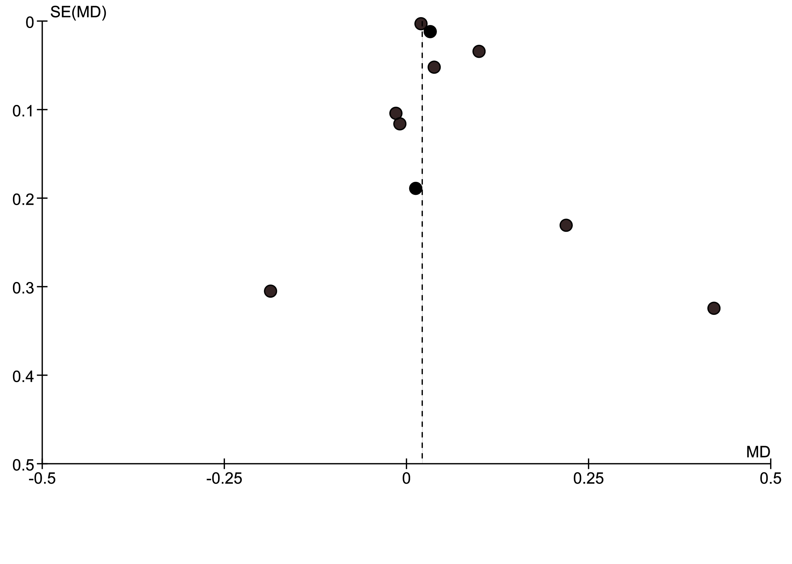
Figure 1. Assessment of publication bias for studies reporting total cholesterol outcomes

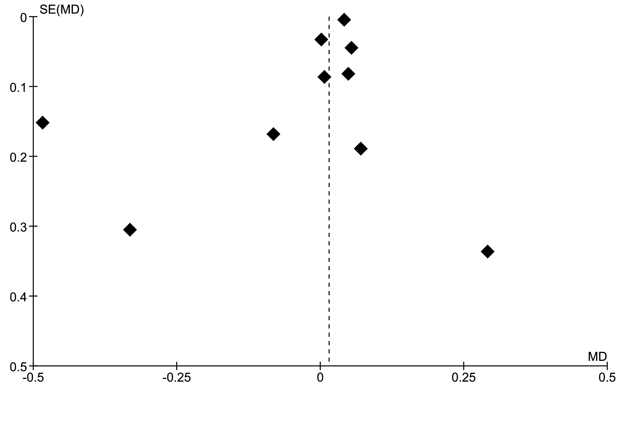
Figure 2. Assessment of publication bias for studies reporting LDL cholesterol outcomes

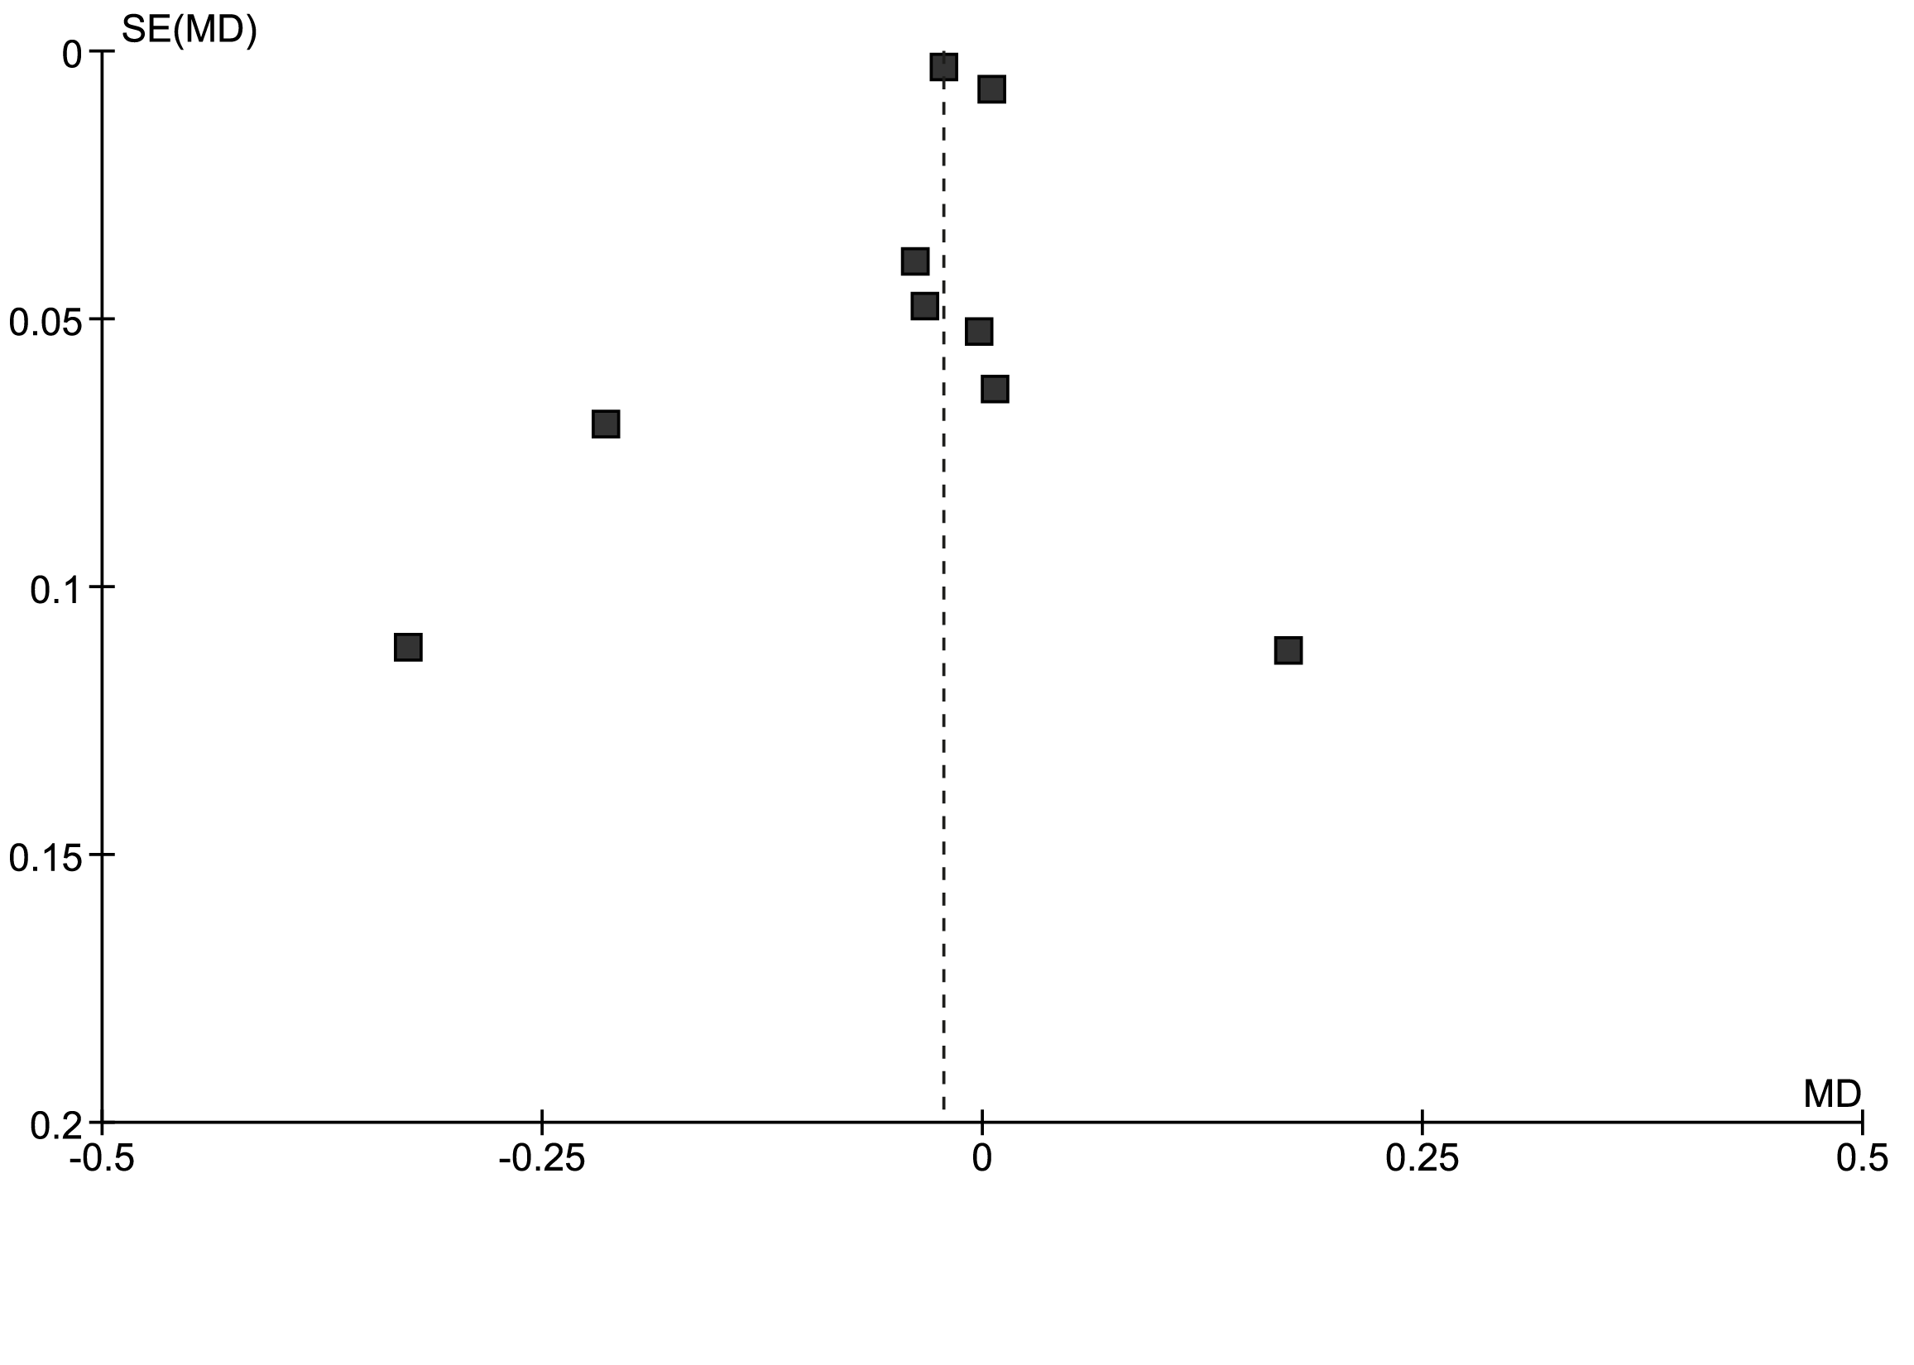
Figure 3. Assessment of publication bias for studies reporting HDL cholesterol outcomes

Appendix 3

Table 1. Summary of GRADE findings

Trans fatty acids and change in total, LDL and HDL blood cholesterol
Patient or population: Humans
Settings: Randomised controlled trials
Intervention: One per cent increase in TFA intake in exchange for cis-MUFA (expressed as a percentage of energy intake)
Comparison: Control
Outcomes | Illustrative comparative risks* (95% CI) |  | Relative effect  (95% CI) | No of Participants  (studies) | Quality of the evidence  (GRADE) | Comments
 | Assumed risk | Corresponding risk
 | Plasma blood lipids | One per cent increase in TFA intake as a percentage of energy intake
Total cholesterol  Follow-up: 3-12 weeks |  | The mean total cholesterol in the intervention groups was  0.02 higher  (0.02 lower to 0.07 higher) |  | 411  (10 studies) | ⊕⊕⊕⊝  moderate^{1,2}
LDL cholesterol  Follow-up: 3-32 weeks |  | The mean LDL cholesterol in the intervention groups was  0.04 higher  (0.03 to 0.06 higher) |  | 2218  (9 studies and 1 existing meta-analysis) | ⊕⊕⊕⊕  high^{2,3}
HDL cholesterol  Follow-up: 3-32 weeks |  | The mean HDL cholesterol in the intervention groups was  0.01 lower  (0.02 lower to 0 higher) |  | 2180  (8 studies and 1 existing meta-analysis) | ⊕⊕⊕⊕  high^{2,3}
*The basis for the assumed risk (e.g. the median control group risk across studies) is provided in footnotes. The corresponding risk (and its 95% confidence interval) is based on the assumed risk in the comparison group and the relative effect of the intervention (and its 95% CI).
CI: Confidence interval;
GRADE Working Group grades of evidence
High quality: Further research is very unlikely to change our confidence in the estimate of effect.
Moderate quality: Further research is likely to have an important impact on our confidence in the estimate of effect and may change the estimate.
Low quality: Further research is very likely to have an important impact on our confidence in the estimate of effect and is likely to change the estimate.
Very low quality: We are very uncertain about the estimate.
¹ Total cholesterol value is determined by both LDL and HDL cholesterol. Therefore, no change in total cholesterol values may mask changes in both LDL and HDL values.
² Dose response relationship plausible
³ Inadequate sample size identified in the majority of studies

The definition of ‘convincing’ evidence at the time this review was conducted: There are consistent associations between the diet, food or component and the health effect, with little or no evidence to the contrary. There should be a substantial number of human studies of acceptable quality, preferably including both observational and experimental studies and preferably conducted in different population groups. Any intake–response relationships should be supportive of a causal relationship and the relationship should be biologically plausible. Supporting evidence sources should be consistent with the findings of human evidence

